­

**SAGIS Property Map Viewer**

**Instruction Manual**

[www.sagis.org/map](https://www.sagis.org/map)

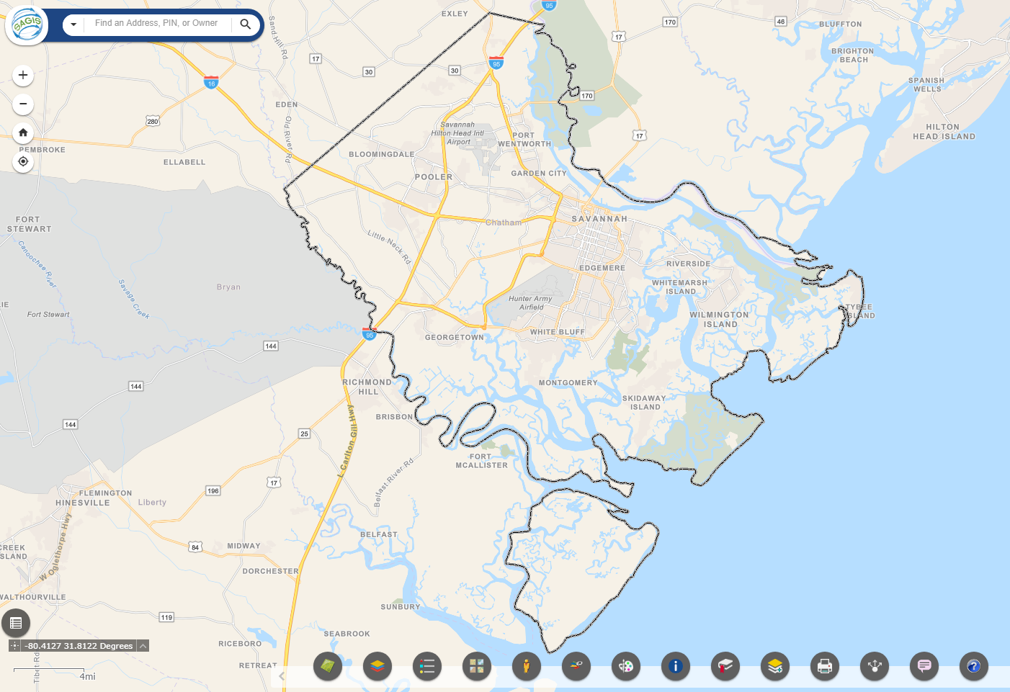

Instructions for using the SAGIS *Property Map Viewer*. Published October 25, 2019.

**Instructional Videos**

*Click on a link below to watch a video on each section on YouTube!*



 [General Map Navigation ⇢](https://www.youtube.com/watch?v=jXCV27ZmcYE&list=PLF-NDdpCXNK-_52wvFpJM9eX8SxnSTLRd&index=3)

 [How to get Help ⇢](https://www.youtube.com/watch?v=xDWcxSZJVfg&list=PLF-NDdpCXNK-_52wvFpJM9eX8SxnSTLRd&index=5)

 [Address Search ⇢](https://www.youtube.com/watch?v=sr0MR7Mxljo&list=PLF-NDdpCXNK-_52wvFpJM9eX8SxnSTLRd&index=1) 

 [Advanced Property Search and Download ⇢](https://www.youtube.com/watch?v=4wlPe3Q20fw&list=PLF-NDdpCXNK-_52wvFpJM9eX8SxnSTLRd&index=2)

 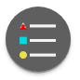 [Map Layers and Legend ⇢](https://www.youtube.com/watch?v=OhSTuQqmDk0&list=PLF-NDdpCXNK-_52wvFpJM9eX8SxnSTLRd&index=6)

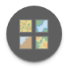 [Basemaps ⇢](https://www.youtube.com/watch?v=vmMbrrNlCuY&list=PLF-NDdpCXNK-_52wvFpJM9eX8SxnSTLRd&index=4)

 [Street View and Google Earth (NEW!) ⇢](https://www.youtube.com/watch?v=W11AzZUxZKM&list=PLF-NDdpCXNK-_52wvFpJM9eX8SxnSTLRd&index=7)

 [Pictometry ⇢](https://www.youtube.com/watch?v=OLWIUJICHVI&list=PLF-NDdpCXNK-_52wvFpJM9eX8SxnSTLRd&index=8)

 [Draw and Save ⇢](https://www.youtube.com/watch?v=wzWwFyQT8Ik&list=PLF-NDdpCXNK-_52wvFpJM9eX8SxnSTLRd&index=11)

 [Measure (NEW!) ⇢](https://www.youtube.com/watch?v=HPb5GajmlZo&list=PLF-NDdpCXNK-_52wvFpJM9eX8SxnSTLRd&index=10)

 [Printing ⇢](https://www.youtube.com/watch?v=89L66T7bG2Y&list=PLF-NDdpCXNK-_52wvFpJM9eX8SxnSTLRd&index=9)

 [Property Printout (NEW!) ⇢](https://www.youtube.com/watch?v=tiT9cU2cgFc&list=PLF-NDdpCXNK-_52wvFpJM9eX8SxnSTLRd&index=16)

 [Bookmarks ⇢](https://www.youtube.com/watch?v=mOdUnOg9JZE&list=PLF-NDdpCXNK-_52wvFpJM9eX8SxnSTLRd&index=15)

 [Identify Features ⇢](https://www.youtube.com/watch?v=SA1hgUVLKr0&list=PLF-NDdpCXNK-_52wvFpJM9eX8SxnSTLRd&index=13)

 **Property Analysis & Advanced Tools Group** (NEW!)

 [Site Selection & Query ⇢](https://www.youtube.com/watch?v=elEZ8SaXsJI&list=PLF-NDdpCXNK-_52wvFpJM9eX8SxnSTLRd&index=19)

 [Save My SAGIS Session ⇢](https://www.youtube.com/watch?v=5MyBEW0mAh8&list=PLF-NDdpCXNK-_52wvFpJM9eX8SxnSTLRd&index=18)

 [Add Data to the Map ⇢](https://www.youtube.com/watch?v=7QzicBBiEBM&list=PLF-NDdpCXNK-_52wvFpJM9eX8SxnSTLRd&index=20)

 [Select and Download ⇢](https://www.youtube.com/watch?v=uYg4BYTw8h4&list=PLF-NDdpCXNK-_52wvFpJM9eX8SxnSTLRd&index=22)

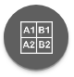 [Create a Map Book Grid ⇢](https://www.youtube.com/watch?v=3CtP7wDWW2Q&list=PLF-NDdpCXNK-_52wvFpJM9eX8SxnSTLRd&index=24)

 [Distance and Direction ⇢](https://www.youtube.com/watch?v=34-kFGyPSjI&list=PLF-NDdpCXNK-_52wvFpJM9eX8SxnSTLRd&index=23)

 [Share a Link to the Map ⇢](https://www.youtube.com/watch?v=E0GgcSoPQ9A&list=PLF-NDdpCXNK-_52wvFpJM9eX8SxnSTLRd&index=17)

 [Location Planning ⇢](https://www.youtube.com/watch?v=OmJfdi4H7JY&list=PLF-NDdpCXNK-_52wvFpJM9eX8SxnSTLRd&index=17)

 [Chart Sale Price, Value and Zoning ⇢](https://www.youtube.com/watch?v=NaVMso48NV8&list=PLF-NDdpCXNK-_52wvFpJM9eX8SxnSTLRd&index=21)



[Watch All Videos (Full Playlist)](https://www.youtube.com/watch?v=sr0MR7Mxljo&list=PLF-NDdpCXNK-_52wvFpJM9eX8SxnSTLRd&index=1) ⇢

**Frequently Asked Questions**

**1. How do I view property record tax information?**

Click on a single property on the map. The info box comes up. Then, click Print Property Record Card ⇢ or Notice of Assessment ⇢ as shown below.

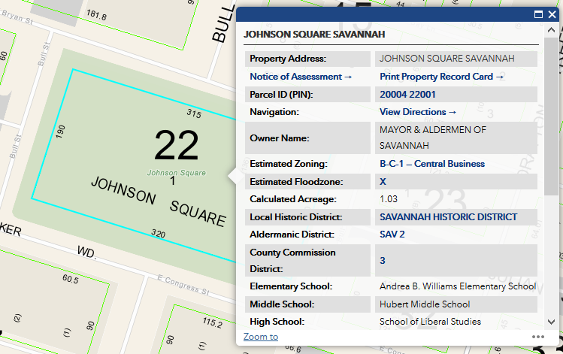

Note: The Property Parcel layer must be turned on. It is already on when you first load the SAGIS Map viewer by default. Zoom in to the neighborhood level to see the green property boundary lines. If you turn the layer off in the Layer List, you must turn it on again to get the Parcel popup info box. Popups display only for layers that are turned on and visible.

**2. Layers won't turn on!**

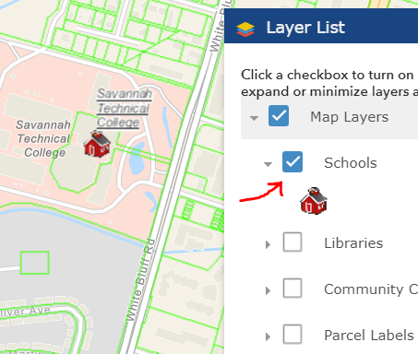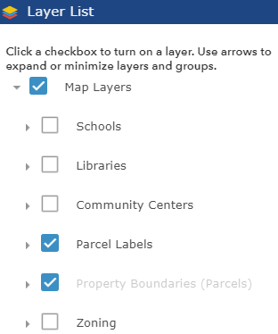Answer: If the layer names are grey, like Property Parcels below, zoom the map in more to see them. If they still do not appear, make sure the checkbox for the layer and its group it is in above it, are also on, indicated by the checkboxes.

# 

# TABLE OF CONTENTS

***Note:*** *These section titles on this page are clickable hyperlinks when viewed on a computer.*

* 1. Introduction P. 7

2.0 Map Navigation P. 9

2.1 Address Search P. 11

3.0 Map Toolbar P. 12

3.1 Parcel Search P. 12

3.2 [Layer List and Attribute Table](#_Layer_List_(Table_1)  P. 17

3.3 Filter by Query and Download P. 21

3.4 Legend P. 23

3.5 Basemaps P. 24

3.6 Google Streetview and Earth (New!) P. 25

3.7 Draw P. 26

3.8 Measure P. 27

3.9 Identify by Selection P. 28

3.10 Bookmarks  P. 29

3.11 Print P. 29

3.12 Property Printout (New!) P. 30

3.13 Share P. 34

3.14 Location Planning (New!) P. 36

Property Analysis & Advanced Tools (New!) P. 39

3.15 Save My SAGIS Session P. 40

3.16 Site Selection and Query  P. 41

3.17 Add Data Layers to the Map P. 51

3.18 Sale Price, Value and Zoning Charts P. 55

3.19 Select and Download Data P. 56

3.20 Distance and Direction P. 59

3.21 Grid Overlay P. 61

3.22 Help and About  P. 63

4.0 Pictometry  P. 64

5.0 SAGIS Contact Information  P. 68

# 1.0 INTRODUCTION

Welcome to the SAGIS Property Map Viewer! This is how the viewer appears on startup. If you encounter problems with this site, first try clearing your browser history, restart your browser and reload the page. See [refreshyourcache.com](http://www.refreshyourcache.com) for instructions on clearing your browser cache and history.



Savannah Area Geographic Information Systems (SAGIS)

SAGIS provides access to geospatial data in a standardized format to all interested parties. SAGIS works with the City of Savannah, Chatham County, The Metropolitan Planning Commission and other government, non-profit and private organizations to maintain standards, manage data, educate and coordinate projects that affect the greater Savannah - Chatham County area. SAGIS shares this geographic data with the public through the [SAGIS Map Viewer](https://www.sagis.org/Map) and [SAGIS Open Data](https://data-sagis.opendata.arcgis.com/). We also support geospatial education in our community through the organization of [GIS Day Savannah](http://gisdaysavannah.org/) every year. Savannah Area GIS is governed by the [SAGIS Board](https://www.thempc.org/Board/Sagis).

There are three main sections of the map viewer: Address Search, Map Navigation and the Toolbar.

Each button and tool and its use is described in this document.



Address Search

Map Navigation

Toolbar

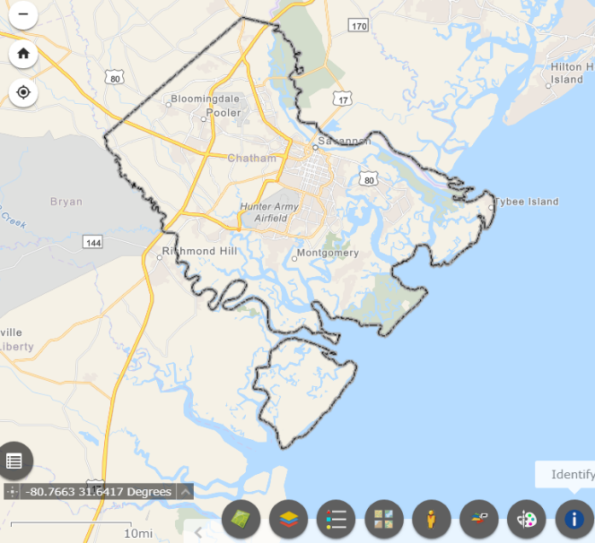

**Saved Map** When you open the site, it asks if you

want to reload where the map was zoomed to, and

what layers were turned on. To reload the saved map,

click the popup message in the lower-right.

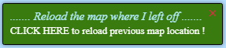

# 2.0 **MAP NAVIGATION**

When you first open the map, you can click the mouse and hold down, and then drag, to move the map. Left-click on the map, keeping the left button held down, and then drag your mouse to move the map. Map navigation is similar to Google Maps and other popular map websites.

You can always zoom in and out by using your mouse’s scroll wheel. Scroll up to zoom in. Scroll down to zoom out. Use the + / - buttons as described below.

 **Zoom In**

Click the Zoom In tool to zoom the map in one level.

 **Zoom Out**Click the Zoom Out tool to zoom the map out one level.

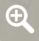 **Quick Zoom In To Area**

This capability is integrated as a keyboard shortcut. Hold the Shift key down. While keeping the Shift key held down, click and hold down the left mouse button and draw a box of an area to zoom to. Click the mouse, drag down and to the right or up and to the left, then release the mouse button. A box in red will show where the map will zoom to once you release the mouse.

Pinch to zoom on mobile devices.

 **Zoom Previous**

Click the Zoom Previous button to return to the last area of the map displayed. This can repeated multiple times. If there is no previous area available, nothing will happen. The map area displayed on screen is called the map ‘extent’ in GIS terminology.

 **Zoom Next**

Click the Zoom Next button to go to the next extent display. This is only possible if you clicked the Zoom Previous button. If there is no next extent available, nothing will happen.

 **Home**

Click the Home button to zoom the map out to Chatham County.

 **Full Screen**

Click the Full Screen button enter a full screen display. Press the Escape key to leave full screen.

 **Map Overview**

The Map Overview is located in the bottom-right of the screen. It is mini map, showing a view of the area on screen in the big map as the dark rectangle within the larger region. It is a quick way to see what general part of the county you are in, if, for example, the big map is zoomed down to a neighborhood or block. Click the ‘eye’ to open or close it.

# 

# 2.1 **Address Search**

You may search for addresses by Address Point, properties by Owner Name or Parcel Identification Number (PIN), and Businesses - Points of Interest by name. By default all sources are searched. To switch to using only one locator, click the dropdown arrow on the left side. Results now auto-complete!

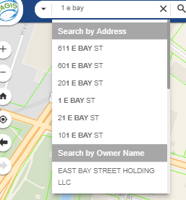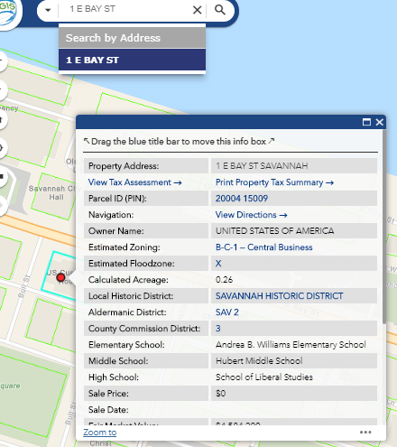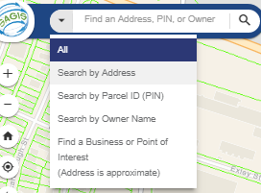

**To view information for a property**, click its address in the Results address list that pops up, or click on the property itself on the map. (Example for an address search: 1 E Bay St)

When you click to select the address result the **first** **time**, it will show a red dot • on the address result. Click the result **again**, a **second** **time** to see the property info box popup.

**Note the PIN format was updated July 2019 and PINs have a new format**. There are no longer dashes in the PIN. Where there was a dash, it has now been removed. Most PINs have spaces in the middle, such as 20032 63001 for Forsyth Park. If the PIN contains a letter in the middle there is no space, as it takes the place of the space, such as 10993C01034. For details on this change by the Chatham County Tax Commissioner and Board of Assessors see [www.chathamtax.org](http://www.chathamtax.org).

The Point of Interest search uses the Esri ArcGIS Online [locator](https://www.esri.com/en-us/arcgis/products/world-geocoder-for-arcgis) to find any business or point of interest within Chatham County and neighboring areas. Results and address locations returned by the Esri Point of Interest search are approximate. The address may not be the official address or exact location but this capability is included to enable searching by business names and point of interest names; such as ‘Memorial Hospital’, ‘Publix’, ‘Daffin Park’ or ‘Grayson Stadium’.

# 3.0 **MAP TOOLBAR**



# **Parcel Search**

You can search for a parcel of property by Property Address, Owner Name, Parcel ID Number (PIN), or by drawing a search area on the map. The Parcel Search tool enables you to search for multiple properties with advanced options and to download results to a table file.

To search by address, use the address number and street, with a direction letter if needed (N, E, S, W). To search for a specific parcel, do **not** include the street suffix. (For example, do not use “St or Street”, for 110 E State. Simply just use ’110 E State’ for best results, as in the example shown.)

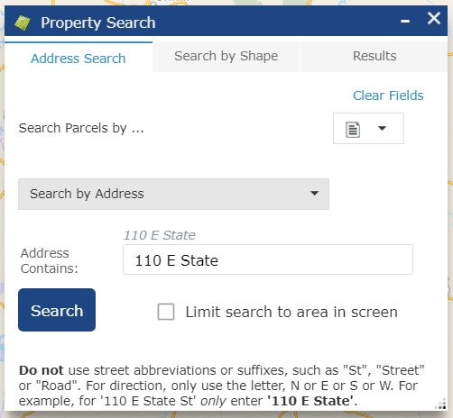

Leaving out the lot number and searching only street name will yield all properties addressed to that particular street. (For example searching just ‘E State’)

**Note that address points may differ from the parcel address**. There may be multiple address **points** or units on a particular **parcel** of property. The Address Search tool above uses the **Address Point**, which is usually on a specific building or unit. In contrast, this tool, the Parcel Search, searches the **Property Address** for the parcel as stored in the Property Parcel polygon dataset maintained by the Chatham County Board of Assessors.

To search for a property by Owner or Parcel ID Number (PIN), change the search method from Search by Address, as shown below.

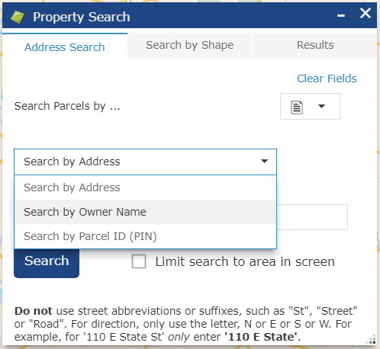

To search by drawing, select a property or multiple parcels of property with a point (), line ( ), or polygon outline (). A point will select a single property in the layer whereas lines and polygons can highlight multiple parcels of property as shown below.

Step 1. Choose a drawing method:

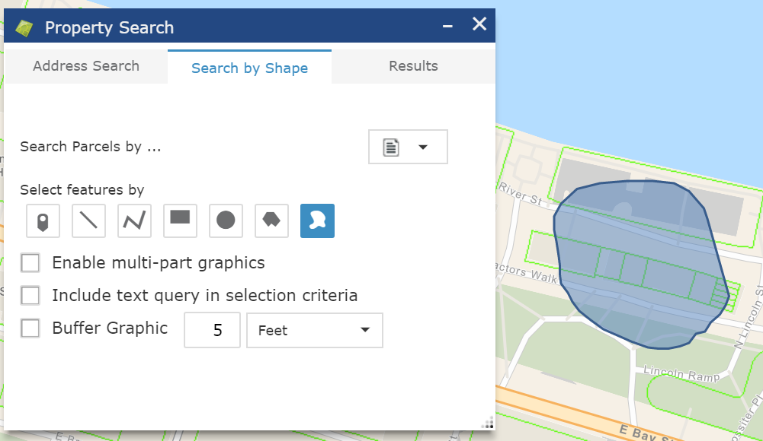

Step 2. Draw an area with the tool and your results will be selected, shown on the map and in the list:

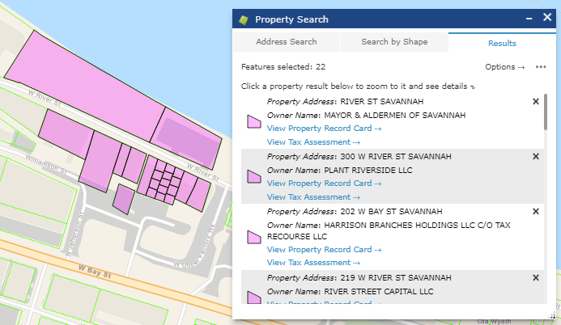

You can buffer the selection tool to include areas of a given distance around a point, line or polygon.

The properties within the buffered area will be selected. You can share a link to your search results with anyone. Choose “Export Search URL” below. When you open the shared link, you will need to open Parcel Search to see the results.

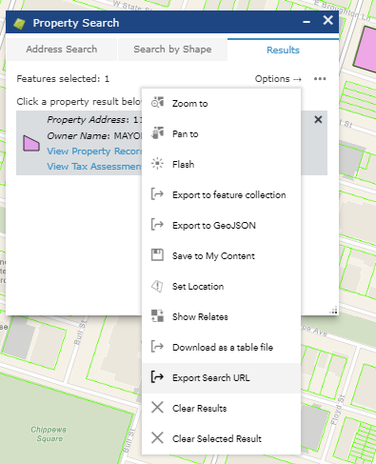

You can **download the tabular data for a parcel** or a list of parcels returned by the search results. Choose ‘Download to a table file’ as denoted above with the red arrow. This can be opened by Excel and other spreadsheet apps.

To see full information for a parcel, click on the feature shown in purple on the map, to see its info box:

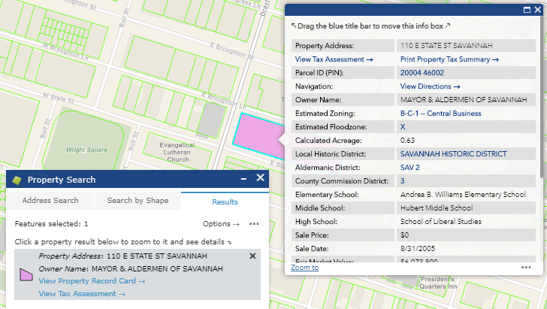

To buffer around a point and select parcels within a given distance, enter a number and a unit such as Feet. Any parcels within that buffer distance will also be included in the selection Results. For example, perhaps you want to include all parcels with 150 feet for a public notice of a development project (shown below). Keep in mind, it will buffer from the point in the property where you click, and not the parcel boundary itself, and so you may need to add the extra distance between the selection point and the property boundary to your overall buffer distance.

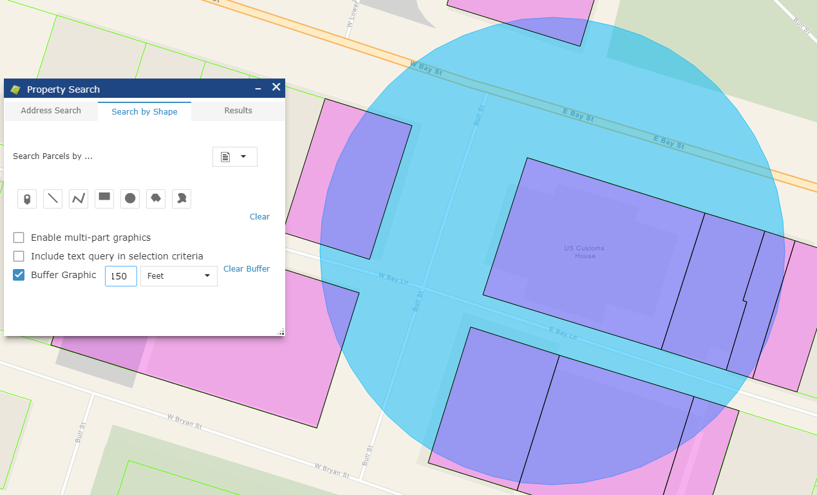

To select several areas at once, click “Enable multi-part graphics”, which allows you to draw multiple shapes around several areas at once. Make multiple selections with the shape selecting tools, and then click “Search” which will appear, to select the parcels. 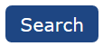

To combine searching by drawing shapes, with text search, click “Include text query”. This can be used, for example, to select all property owned by the City, but **only** along the waterfront. First type in “Mayor” in the Address Search tab under Search by Owner Name. Then, in Search by Shape, enable “Include text query” and draw a search shape around the area of interest on the waterfront.



# **Layer List and Attribute Table**

**To view the information popup for a feature, simply click on a feature in the map**, such as shown below with the Parcel layer, which shows property ownership and other information by clicking on a property. If there is more than one feature where you clicked, click the Next or Back arrow buttons:

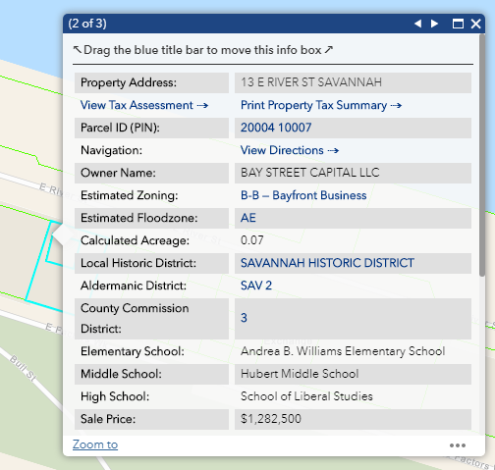

Only layers that are turned on in the Layer List and that are visible, will display on the map and show information when clicked. The **Property Boundaries** (Parcels) layer is already turned on by default. Certain layers, like Parcels,  appear **only** as you zoom in closer. Layer names are grey in the list if they are zoomed out too far to be visible. Zoom the map in to see them, and their names will go from grey to black. Property dimensions and the Chatham County Board of Assessors labels (titled ‘Property Measurements and Labels’) will display once you zoom down to a neighborhood level. They are also the only layer that will in fact also disappear if you zoom in **too far**. The reasoning behind this is that the labels will become too large and cover over features of interest such as buildings and streets. The two layers that are turned on by default when you first start the SAGIS Map site up are the Property Boundaries (Parcels) and Property Measurements and Labels. To turn on any other layer, such as Zoning, you must open the Layer List and turn on the layer of interest. **To** **move this popup info box**, simply drag the blue titlebar and you may move it anywhere on the screen, if you want to view what is underneath the info box.

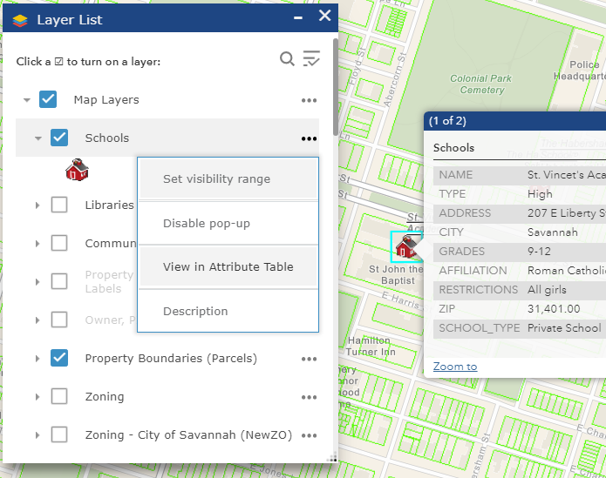The Layer List allows you to **turn layers in the map on or off**. Turn a layer on by clicking the checkbox to the left of the layer name. (Example: Schools) To see the layer Legend 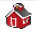click on the layer’s name or its arrow ⯈ To see layer details and options and open the **Attribute Table**, click the three dots () on the right of each layer:

A layer’s Attribute Table can viewed, shown below, and saved as a table file that Excel and other spreadsheet apps can open. Click on ‘View in Attribute Table’ for a layer in the Layer List, such as Schools, shown below. You can sort any column alphabetically by clicking the column titles, like Excel. To close the Attribute Table click the Attribute Table button on the right side of the screen.

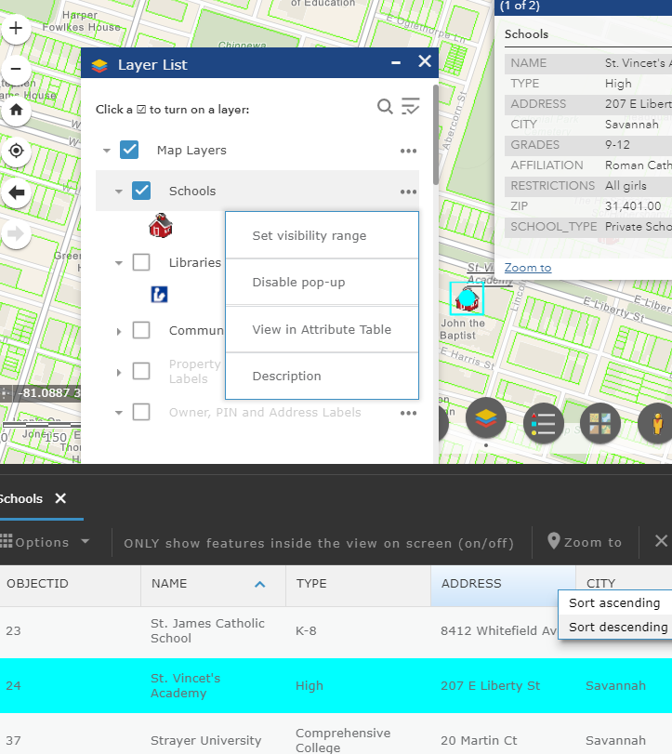

Click to open/close

Attribute Table

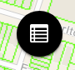

**Click here to open Table**

Drag down to resize

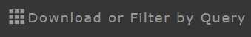

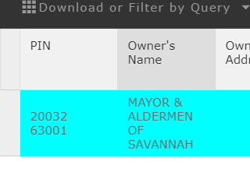The Attribute Table shows only features within the current map view by default. If you want to load all features of a layer in to the table, (i.e. for the entire county) click the “ONLY show features inside the map view” button to deactivate this restriction. Only do this if necessary, as it may slow down loading the loading speed of the site.

To select a row or rows, click on the left side of the row, like in Excel:

It will then highlight that feature on the map as well as in the table.

To view the Attribute Table row for a single feature, click the ‘…’ in a feature’s popup info box. On the flip side, if you want to highlight a feature you see in the attribute table, just click its row and it will highlight on the map and in the table, like a spreadsheet program.

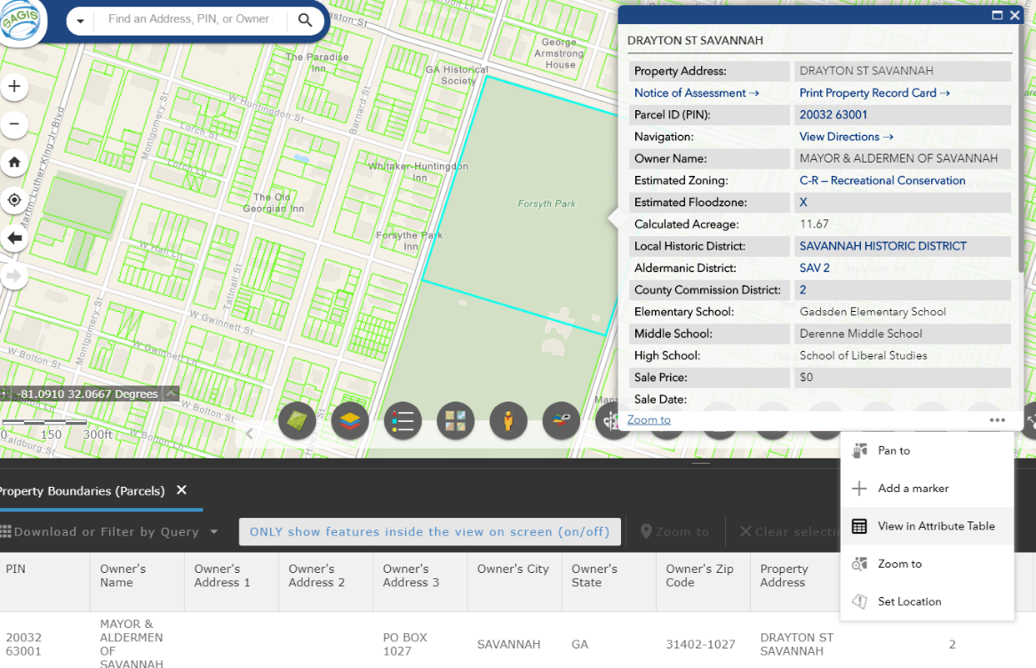

Some layers have been placed into Groups with related layers. Click the arrows (⯈) to the left of Groups to expand them. You can also just click on the layer name itself. Groups are like folders. If you turn a group on, any layers inside this group will turn on, **if** they are **also** turned on. (**Both** levels must be on.)

The layers in Groups in the Map Viewer, as shown below, are the Census (Tracts, Block Groups and Blocks; which are all on by default), LOMAs, and Elevation and Contours (containing Contour Lines, NGS Benchmarks, and Elevation Certificates for the City of Savannah and unincorporated Chatham County).

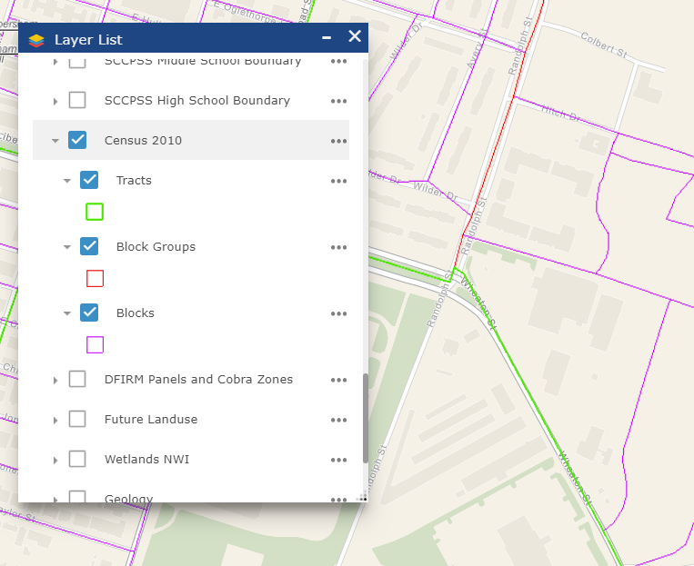 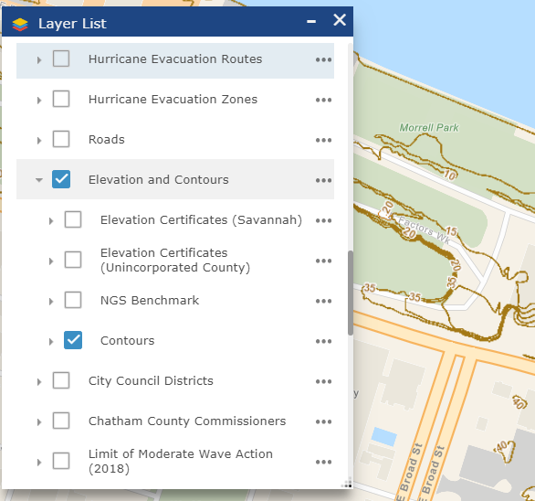

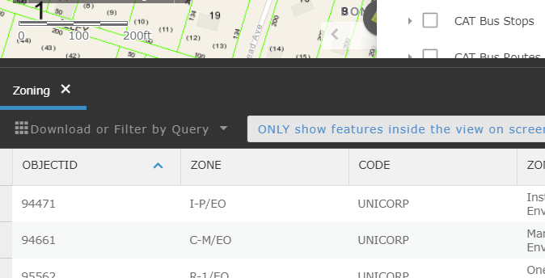

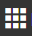

# **Download or Filter by Query**

Click the ‘Download or Filter by Query’ button in the Attribute Table to open the Query Dialog. You can select features from any field in any layer, based on a SQL query. (What’s a SQL Query? [Click here to read more](http://desktop.arcgis.com/en/arcmap/latest/map/working-with-layers/building-a-query-expression.htm#GUID-C05F4A2C-0CE4-4629-A36C-EBCB22E1B7C9).) For example, you could show all properties with a sale price greater than $1,000,000 that are zoned ‘BC-1’ in the parcel layer.

You can have more than one condition to search by with *And* and *Or* and *Not* logic ‘operators’ to string together multiple criteria. For example, the 222 Drayton St parcel meets these criteria. This is referred to in plain language in the SAGIS viewer, where it will say “All of the following are true” meaning “*And*”, or “Any of the following are true” meaning “*Or*” as shown in the following examples.

**Example**:

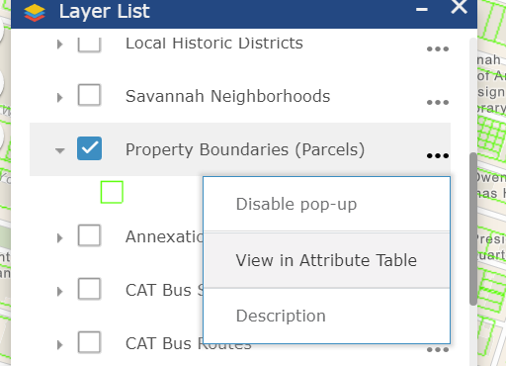Step 1. Select a layer to query. Example: the Property Parcels layer. So, go to the layer ‘…’ options button and click ‘View in Attribute Table’.

Step 2. Click the ‘Download or Filter by Query’ button in the Attribute Table after it opens.

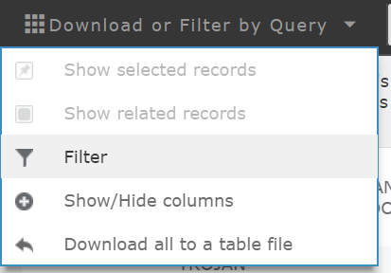

Step 3. Click the Filter button.

Step 4. Choose whether to add a query Expression or Set. A ‘Set’ is if you need to string multiple conditions together with ‘And’ or ‘Or’. Otherwise, if you have only one condition use ‘Expression’.

Step 5. Select a field to query. In the following example for an Expression, we simply want to show only property owned by the City of Savannah. So, we search for the Owner’s Name that ‘starts with’ “mayor &” because that is how the Owner Name for City property starts. It shows only properties owned by the City of Savannah now: (and a few with the last name Mayor, which you could remove manually)

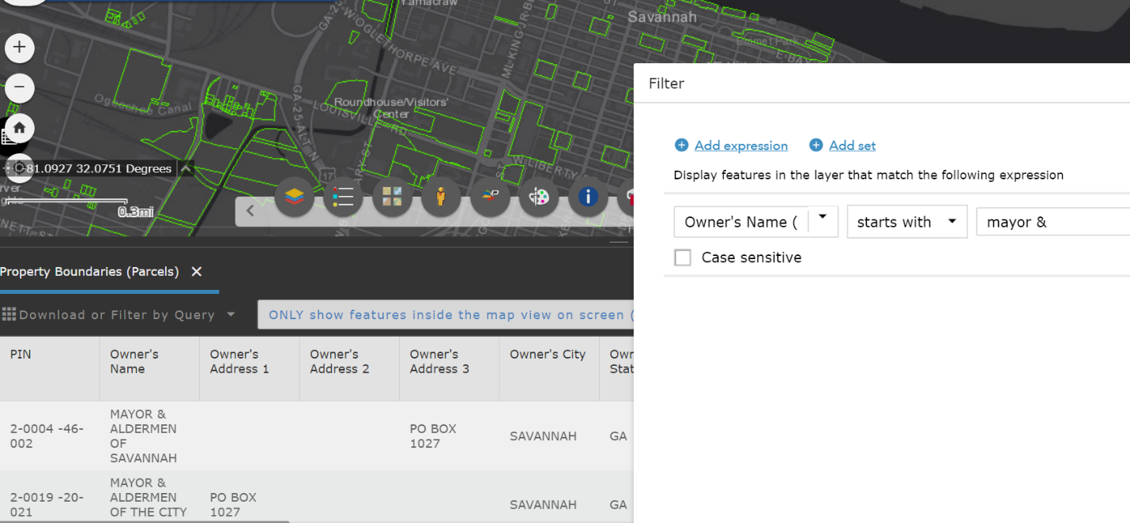

In this other example of a ‘Set’, shown below, we want to show City-owned property that is **also** from a sale price that is at least (i.e. greater than or equal to) $100,000.

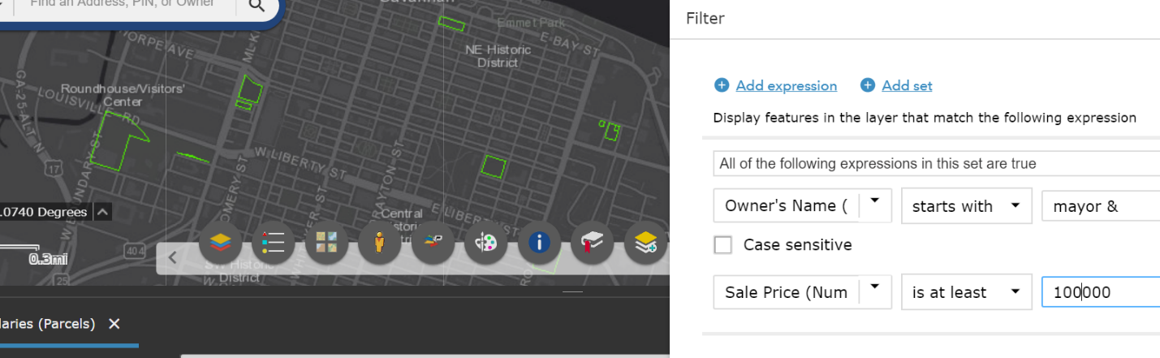

# 

# Legend

The Legend displays the legend symbology for the map layers that are visible on the map, which can be turned on or off in the Layer List as described above.

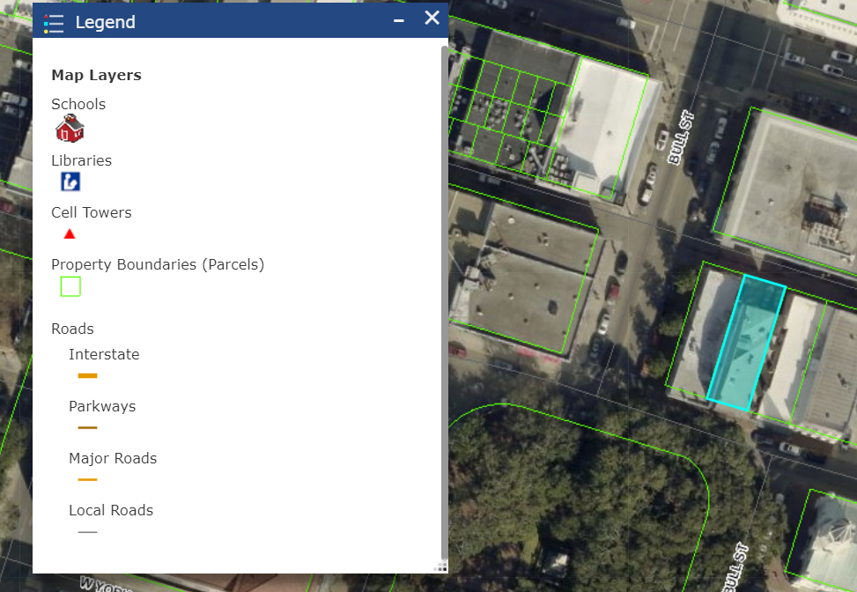

# **Basemaps**

The Basemap menu can change the map background to a variety of basemaps provided by ESRI and the 2008, 2009, 2011, 2013, 2017 and 2018 imagery datasets acquired by SAGIS. The default basemap that is on when you first open this site is the Street Map basemap by Esri. These background maps are for general reference; the current Esri basemaps use data submitted by SAGIS to Esri typically annually in spring; to see recent roads and other features turn on the appropriate layers, such as Roads in the Layer List. SAGIS typically updates the vector data (the map layers in the Layer List) once each quarter.

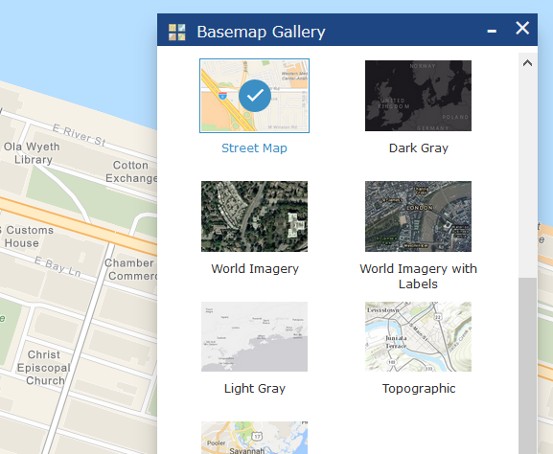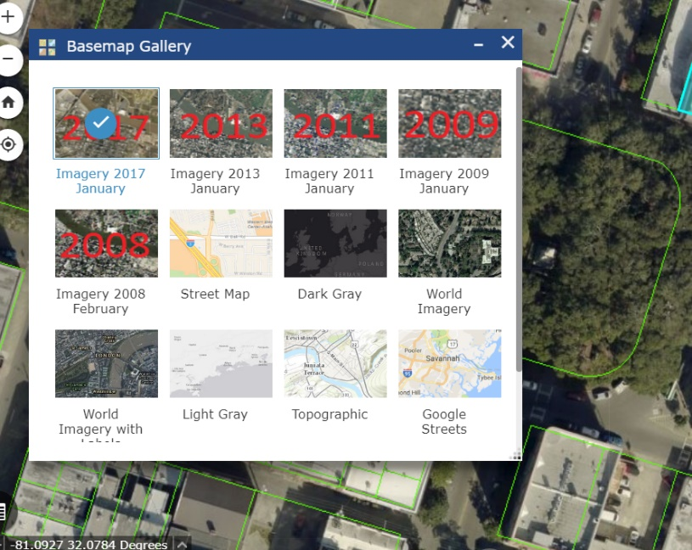

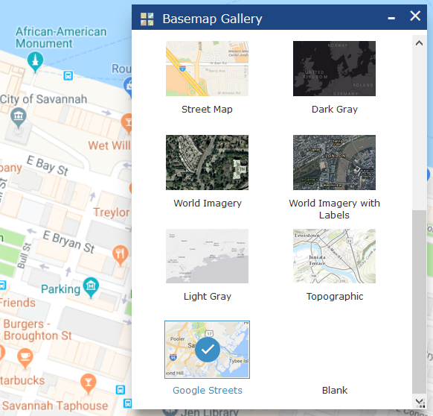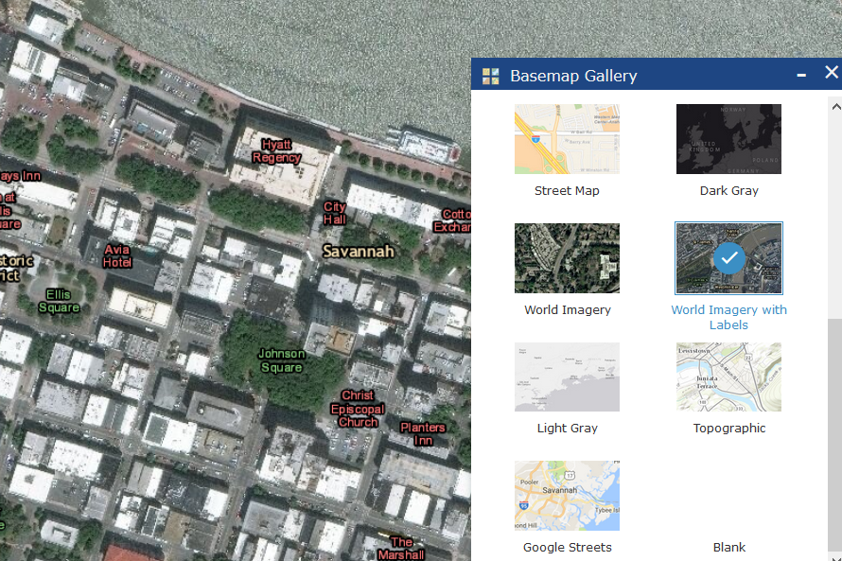

# **Google Street View and Google Earth**

The Street View button opens the Google© Street View™ and Earth™ tools. To use:

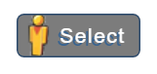1. Click on the Google Street Views ‘Select’ button and the mouse cursor will become a Street View pointer icon.

2. When you click on the map, a new window or tab (depending on user preferences) will open in the browser to Street View. The Google Street View will open, at the point where you clicked on the map. (If there is Street View for this location available.)



**NEW!** A new capability has been added: Google Earth.

****1. Click on the Google Earth ‘Select’ button and the mouse cursor will become a Google Earth pointer icon.

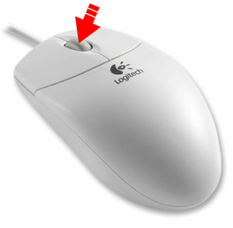2. Click on the map, and Google Earth will open for this location in a new window, at the point where you clicked on the map. You will be able to rotate the map, fly around and tilt the 45 ° imagery and see 3D buildings and terrain (where available). To view 3D imagery where available, click and hold down on the middle mouse button or wheel and then while holding it down, move the mouse to rotate the view.

Note: Google Earth currently requires [Chrome](https://www.google.com/chrome/).

SAGIS is not in any affiliated with or endorsed by Google, and the Street View window functions independently from the main SAGIS map viewer. This tool opens Street View and the new window behaves as if you navigated to the location manually in Google Maps.

# **Draw**

The Draw tool allows you to draw lines, arrows and shapes on the map and place text notes on the map. These will display on the printout as well. You can save your drawings and then load them onto another computer, via a small file (1 kb) that can easily be emailed. You can optionally display measurements and dimensions, such as lengths of lines and area of shapes, in units like feet and acres. You can choose various colors, line thicknesses and transparency levels.

To save your drawings click the “Export Selected Drawings” download button.  Then reload them with the upload button. You can save some or all items, based on which checkboxes are ticked off for each drawing item, on the left side. Your drawings will also automatically save in your browser cache and display the next time you open the SAGIS Property Viewer. Think of this as a temporary holding spot for your drawings – because unless you save them to a file, they will be deleted if you clear your browser cache and history.

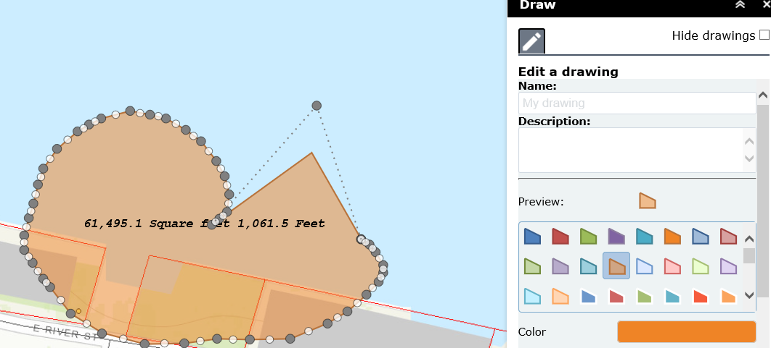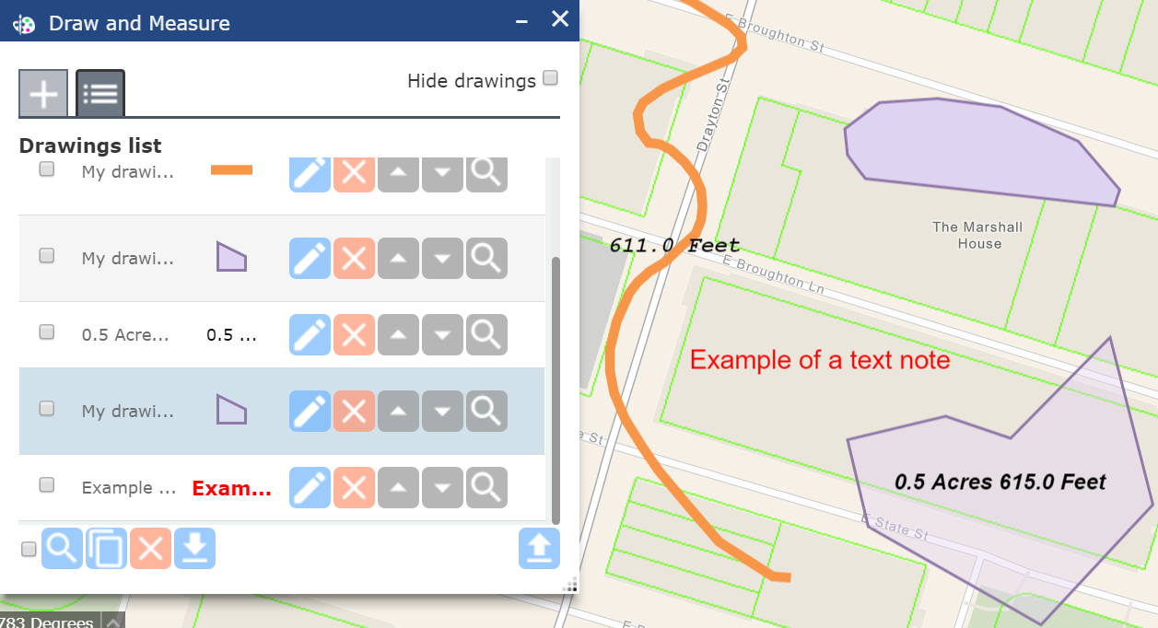

You may edit drawings after creation

with the Update button.

Measurements will automatically be updated

after you save your edits.

# **Measure** (NEW!)

The Measure tool allows you to draw lines and shapes to show measurements. It differs from Draw only in that it has a more streamlined interface design, meant simply for making measurements. It can also measure Bearings for lines and it labels distances along the line for readability. To make a quick measurement, you can use Measure to reduce the number of clicks you need to make. However, to be able to **save** measurements and drawings, and edit them after you draw to make adjustments, you must use the more full-featured Draw tool (as above, in the previous section).

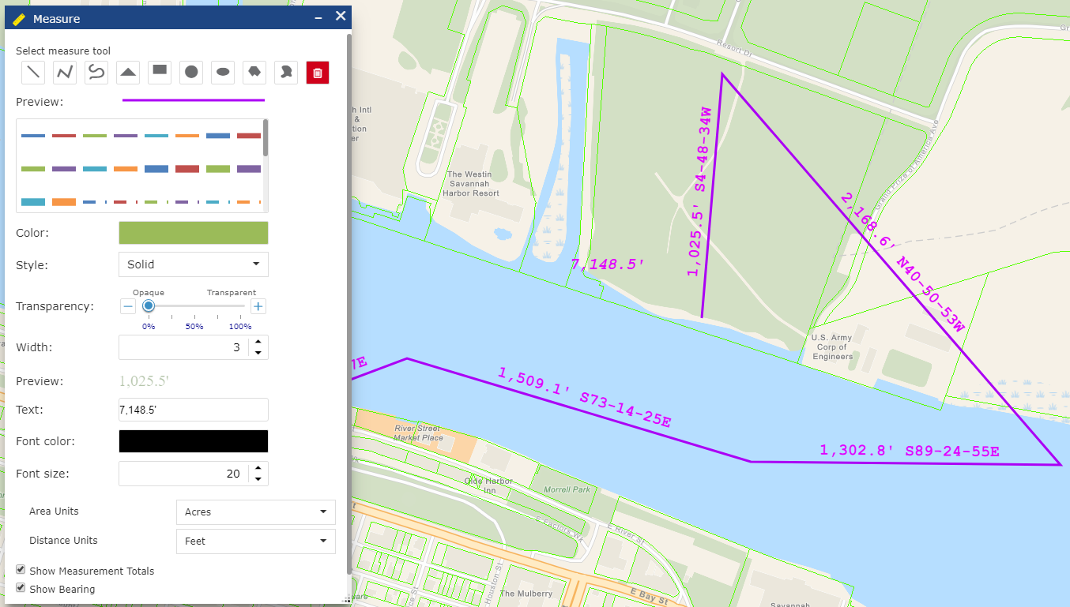

 Identify by Selection

Choose a layer to select by drawing and show info for. Property parcels are shown below as an example.

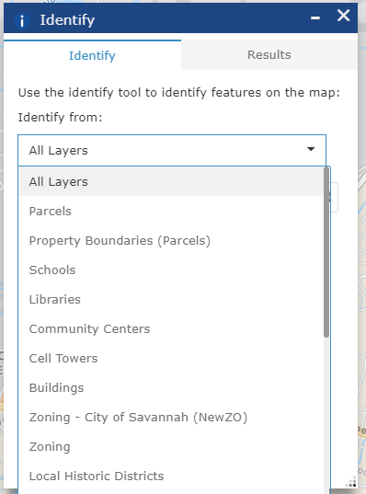Select layer features either with a point (), line ( ), or polygon outline (). A point will select a single feature (i.e. a single building) in the layer whereas lines and polygons can highlight multiple features (i.e. multipe buildings, for example).

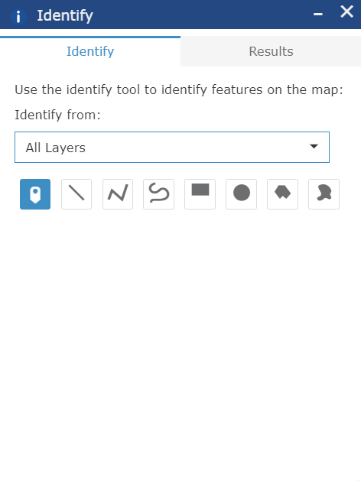

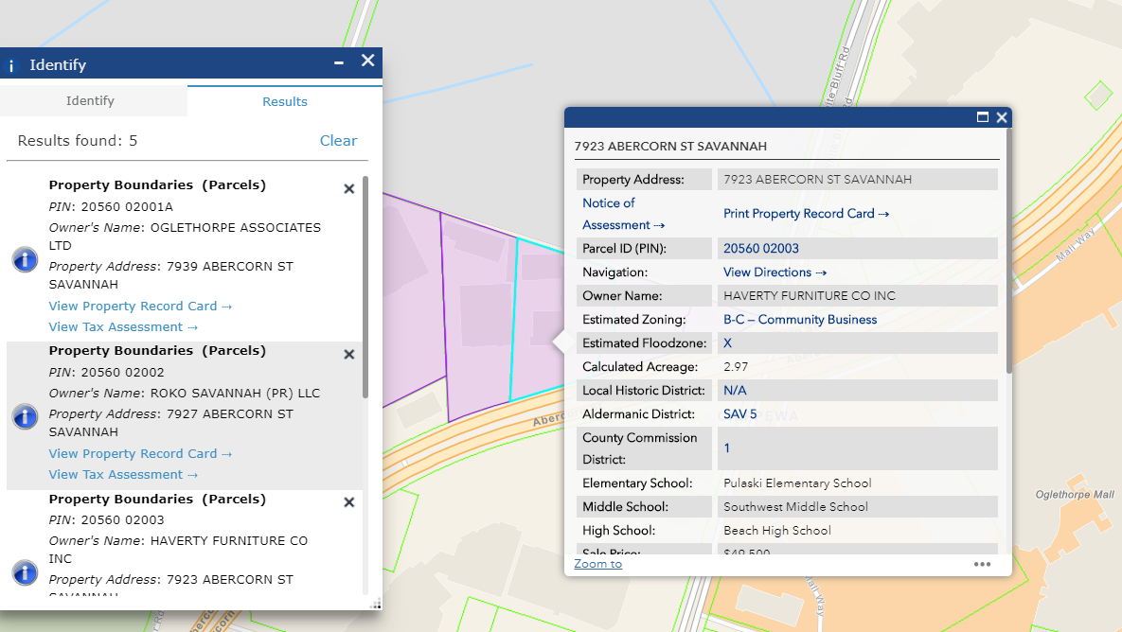

# **Bookmarks**

Bookmarks allows you to create a ‘bookmark’ which saves a spot on the map. The location and zoom that you are currently looking at, will be saved. This will be saved on your local machine until you clear your browser cache.

There are also a list of preset Bookmarks for common landmarks and neighborhoods around the county. Click on the picture button for each Bookmark to navigate the map to it.

# **Print**

Click the Print button to open the Print Dialog. It saves to PDF 8.5x11” letter-size by default, but you may save to JPG or other formats in the format menu, and choose paper sizes and landscape or portrait orientation as Layout options. Tabloid size is 11x17”.

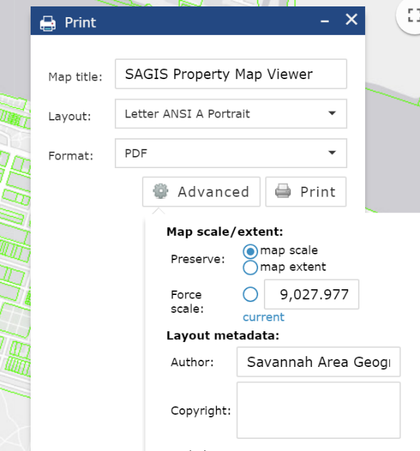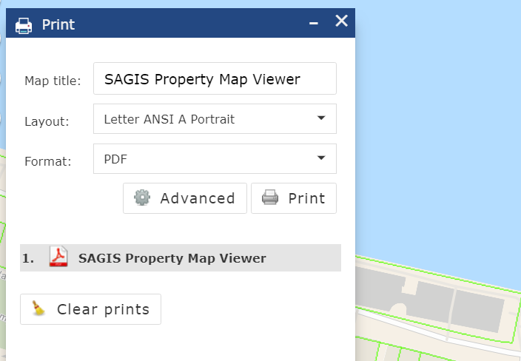

Enter a title for the map and select a layout. Press the ‘Print’ button and the SAGIS Map Viewer will sssscreate a PDF file. It may show an animated progress bar for a moment while it is preparing the print.

Click the printout’s name, to open it in a new window. By default, the title is ‘SAGIS Property Map Viewer’ but you can change this. Popups **must** be enabled**.** If you create more than one printout, they will all be listed in order. [Click here to read how to enable popups in various browsers such as Chrome.](https://www.isc.upenn.edu/how-to/configuring-your-web-browser-allow-pop-windows)

In the Advanced menu, you can see current the map scale, by clicking the word ‘Current’ (shown above).

# 

# **Property Printout** (NEW!)

Click the Property Printout button to open the tool. It can create a printout with a table of property attributes (owner name, sale price, zoning, etc) along with a map of the property you have selected. You can choose whether to display all the property attributes (as in the popup info box) or just some of the attributes, as shown being chosen, below. You can search by typing in an address, or by using the drawing selection tools to select either one or more properties visually. For best results, search for the address number and street but do not use a suffix. As with all other address searching in the SAGIS Property Map Viewer, use the direction letter (N, E, S or W) for direction and do not use a suffix like St or Street. Just the street name by itself. For example, for 1 East Bay Street, you’d type “1 E Bay” in the search.

Once you have found a parcel or parcels of property, click “View Report!”, then click on the Printer button to see the property map and table of information for each property.

Example: Finding a property by searching an Address (1 E Bay)

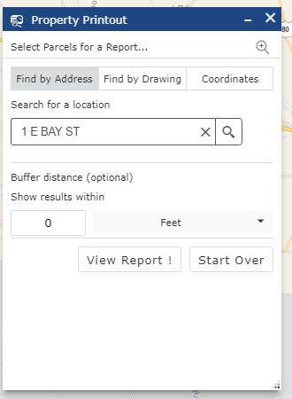 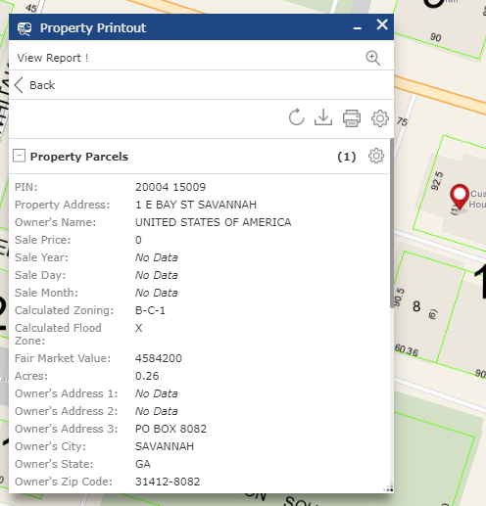

Click “View Report”

Example: Finding parcels by drawing (using a Line, selecting 15 parcels):

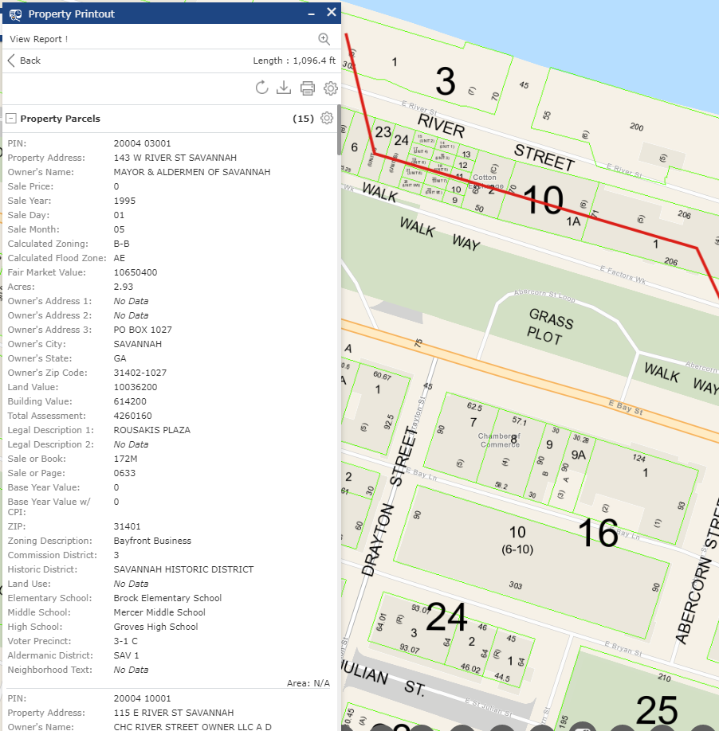

To download the tabular data to a CSV table file that Excel and other spreadsheet apps can open, click the Download button  next to the Print Report button.

An example of the Printout with the Map and Table of info chosen to include is show on the next page.

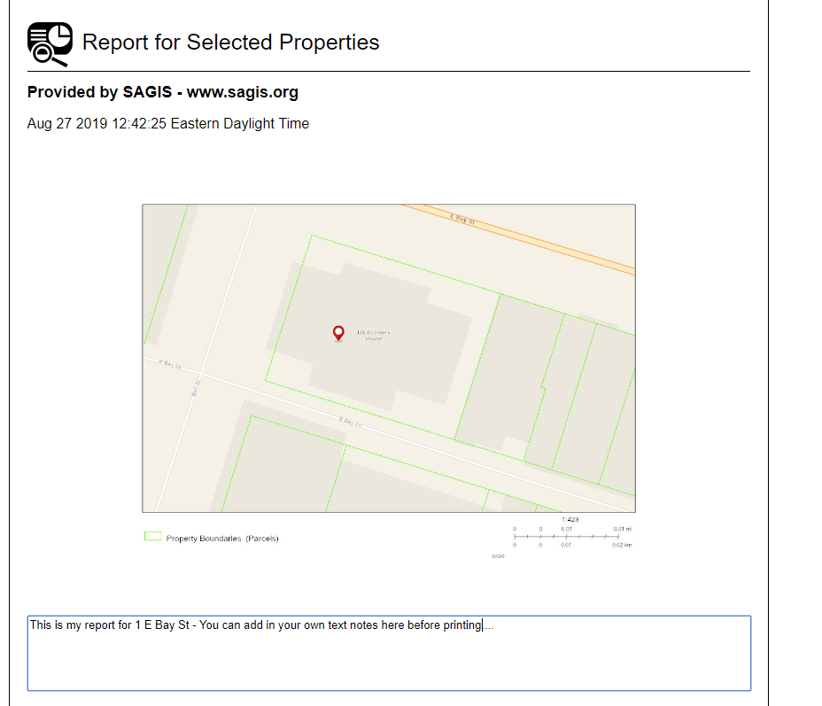

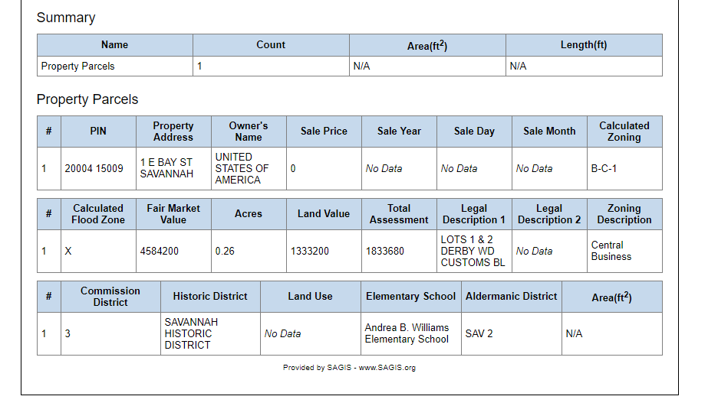

To choose what attributes you want to show, you can select them by clicking the Settings gear: 

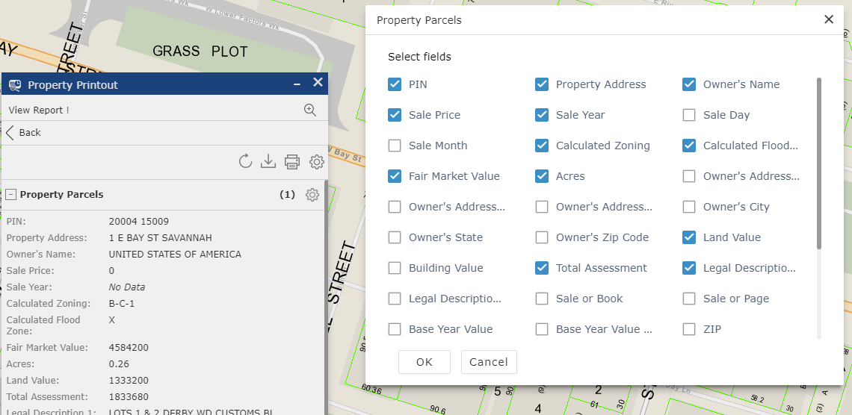

To select parcels by coordinate and enter azimuths and bearings, click the Coordinates search tab.

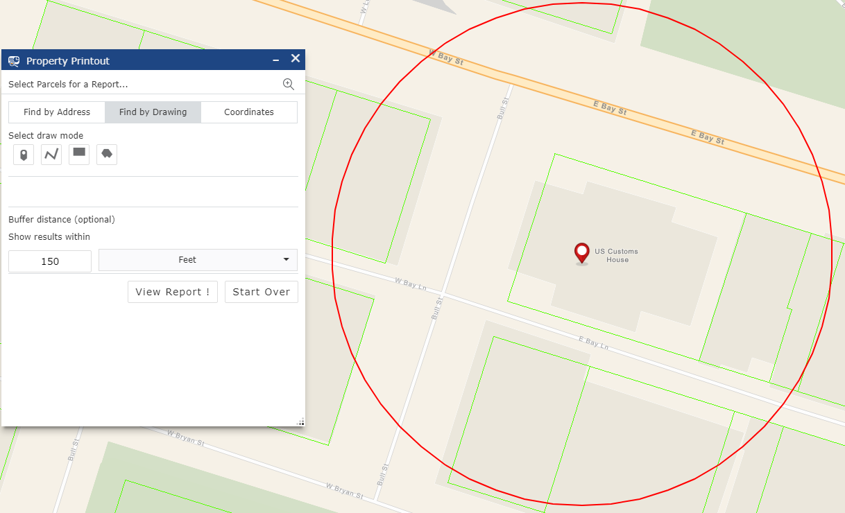To buffer your search selection, enter a number and a unit such as Feet. Any parcels within that buffer distance will also be included in the report. For example, perhaps you want to include all parcels with 150 feet for a public notice of a development project (shown below). Keep in mind, it will buffer from the point in the property and not the parcel boundary, and so you may need to add the extra distance between the point inside the parcel and the property boundary line to the overall buffer distance.

# **Share**

The Share button allows you to share a link to the viewer with anyone else.

You can share a link to the area in the map where you are zoomed in to. (For example if you are zoomed into an area on the riverfront) Simply copy the link below and paste to an email or elsewhere to send to someone. Or, click one of the Social Media buttons to share the link to this area of the map.

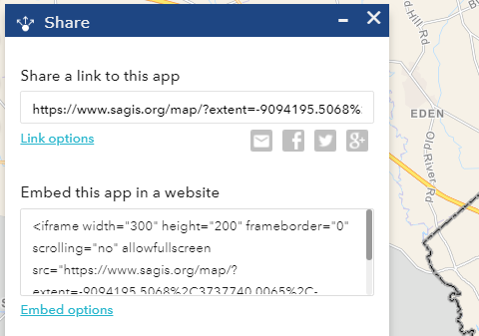

You can also share a link to a specific feature in a layer with a query pre-loaded. This can be used to send a link to a specific property or address to someone. For example, to send someone a link to load the map at “110 E State St”, follow these steps:

Step 1. Click on Link Options as shown below.



Step 2. Select ‘Query a feature and zoom to it’

Step 3. Select a layer and a field. Then, select a value from the address list. You may need to **wait** a moment for the list (addresses, in this example) to load. Be patient if it pauses. Then pick an address. You can also start typing, such as typing ‘110 E St’ once you have the address menu dropdown open, to move right to that entry (or any other kind of attribute, such as owner name, PIN, etc.)

Step 4. Copy and the link to share from the Preview box or use the Sharing social media buttons.

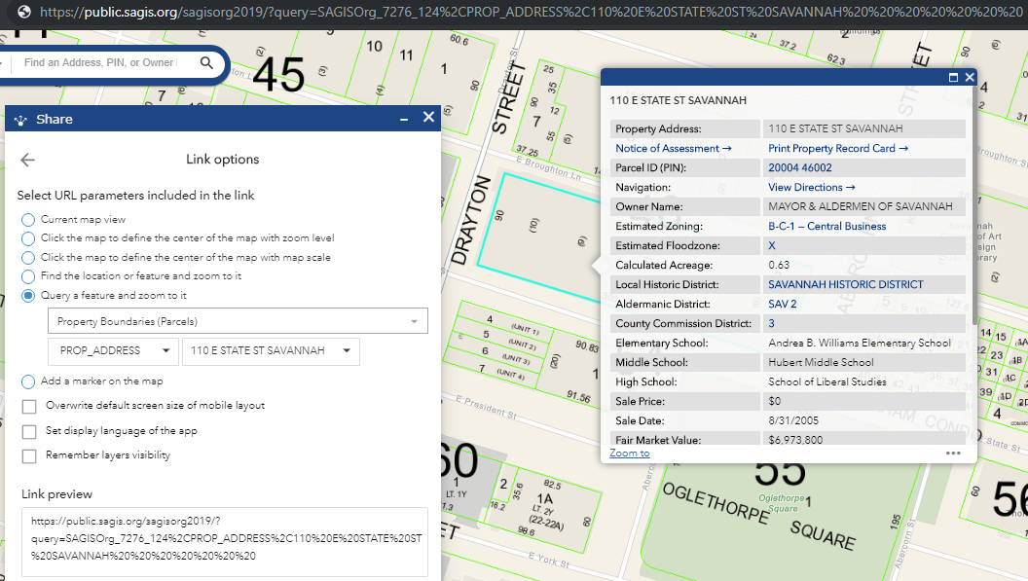

You can also define the scale and center of the map to share along with other options as above.

# Location Planning (NEW!)

The Location Planning tool summarizes several layers within a certain distance you specify: Total Population, Schools, Libraries, Community Centers, and Parcel Values. The total population is from the Census 2010 by blocks. Parcel values contain mininum, maximum, averages and totals for Sale Price, Fair Market Value, Acreage and Land Value. Shown below is a 1-mile buffer around 22 International Drive. First, select your distance (such as 1 mile, or 0.5 miles, and so forth; distance is only in miles).

Then click on your point of interest to center the analysis around. It will show the various categories. Below is an example of the parcels around this point of interest:

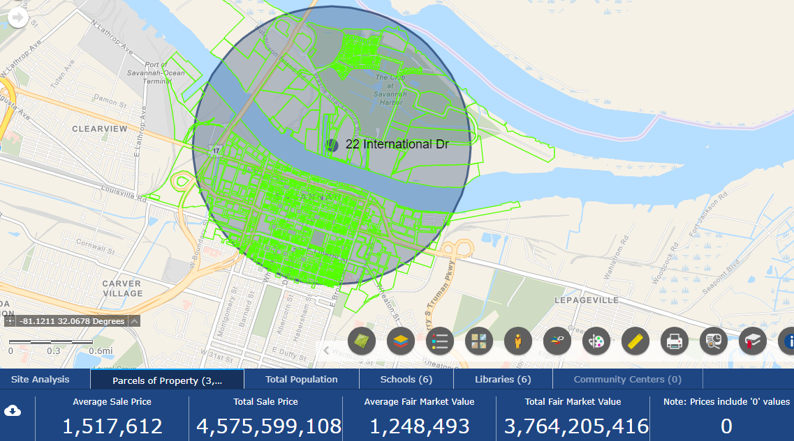

Below is the Total Population from the Census 2010 Blocks for this same point of interest. Notice how if any of the Census block intersects the area of interest, even if it is not entirely within the buffer distance, it will be included. In other words, it could potentially be an overestimate. However most census blocks are fairly small (the size of a city block) unless they are sparsely populated, such as areas of marsh or rural areas so it should be a reasonable estimate.

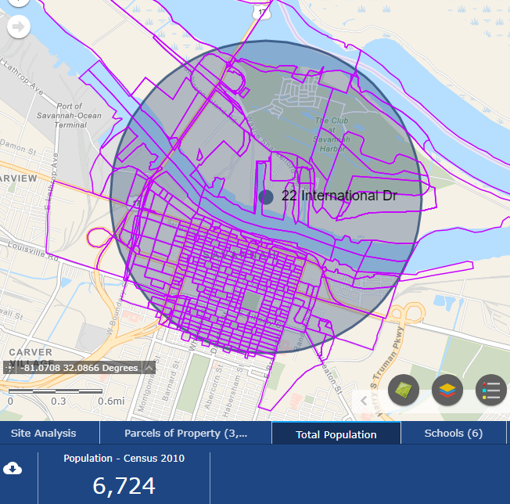

Note that you can download any of these layers as a table file CSV that Excel and other spreadsheet apps can open. The example below shows Schools, where we have clicked the ‘Download’ button, and opened it up in Excel. This will allow you to see the full range of data in the layers, such as for Schools the School name, Type, Grades, etc.

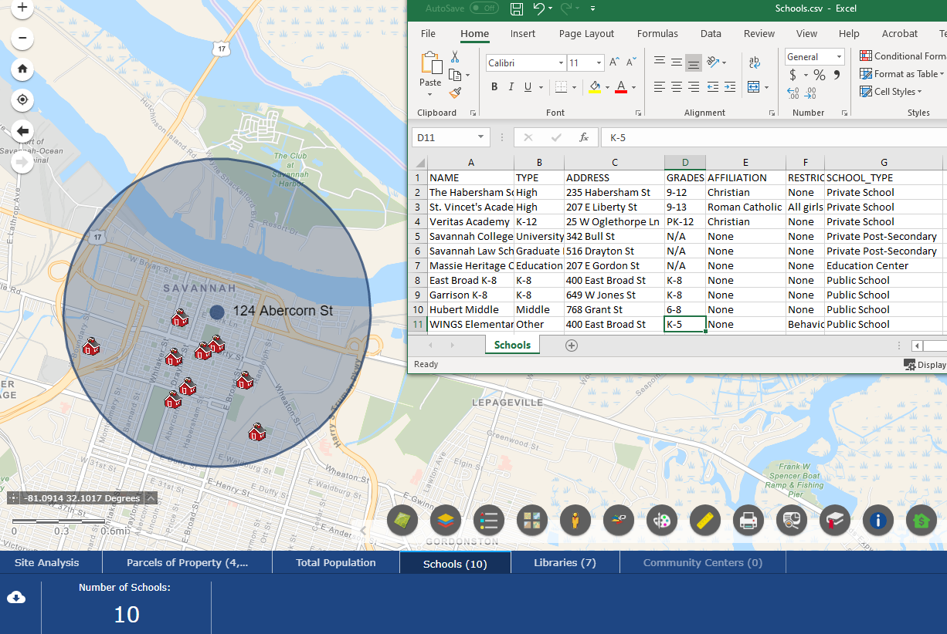

To close Location Planning, click the ‘x’ in the upper right of the blue panel.

Also note you can click on any feature and see its popup info box as usual.

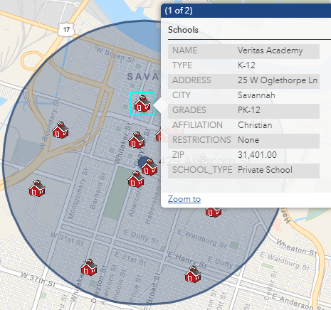

# Property Analysis and Advanced Tools (NEW!)

The Property Analysis Tools section is a new group of powerful tools. Site Selection allows you to query and show properties that are between a certain mininum and maximum sale price, acreage, or value, or a certain zoning, or perhaps meet all these criteria. The Info Charts show attractive bar charts of these criteria for selected properties, Save My Session will save multiple sessions remembering where you are in the map and what layers are on, the Circle buffer tool will draw circles and azimuths, a Download Selection tool allows downloading any layer to a table, and a Grid overlay tool will create quadrats. To open this group of tools, click the Property Analysis and Advanced Tools button. Then, click any of the buttons below to open each tool.

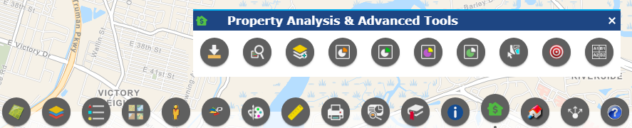

# Save My SAGIS Session

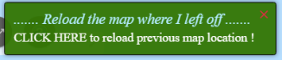This tool allows you to save multiple different sessions. You can restore the map to your last place you left off, with the layers that were on, by clicking the Reload bubble that pops up.

However, this advanced Save Session tool saves multiple locations on the map, and tracks what layers were turned on. For example, below you can see several different locations, one where just Schools are turned on. One, where Zoning is on, and one where Libaries are on. Click on the  to restore layers from the browser cache. If you clear your browser cache you will lose these saved locations, just like with the Draw tool. However, you can permanently save your sessions to a file by clicking the Download button.  This also gives you the ability to send your sessions to someone else or view them on a different computer.

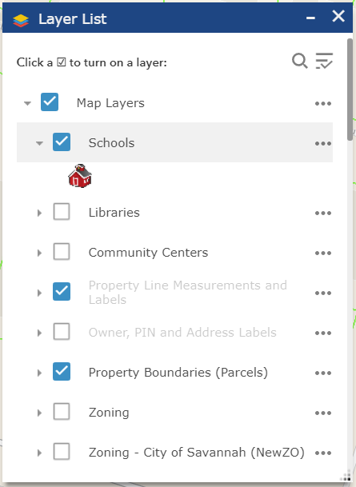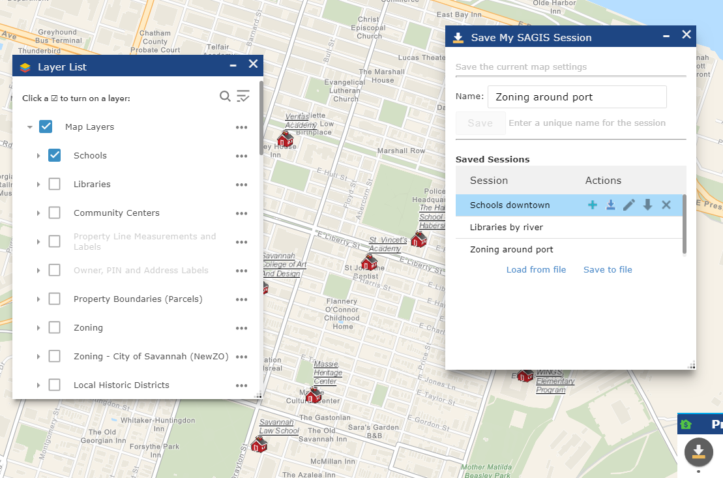

# Site Selection and Query

The Site Selection and Query tool to allows you to query and show parcels of property that are between a certain mininum and maximum Sale Price, Acreage, or Fair Market Value, or a certain Zoning, or any combination of these conditions.

This type of combination query is similar to searching for a product based on multiple criteria, like on Amazon; searching between a mininum and maximum price, review stars, brand, or seller. Or when you have multiple options to choose flights on flight websites where you can include various combinations of conditions. This combination query is shown below. Note that you do **not** use commas when entering values, such as Acres. Similarly, for Sale Price, just enter the number, and not a dollar sign.

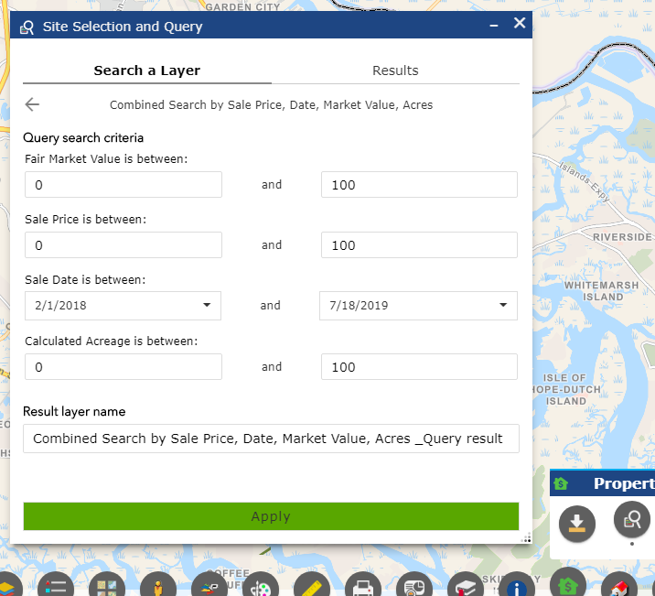

You can also simply search by only one or by only some of the criteria, by leaving the others blank.

Or, **to search by a single category**, click on an individual search type, shown in the screenshot below. There layers that can be searched with a single criteria are: Future Land Use, Schools, Bus Routes, Wetlands, Soil Type, Libraries, Geology, Total Population, and Zoning Boundaries.

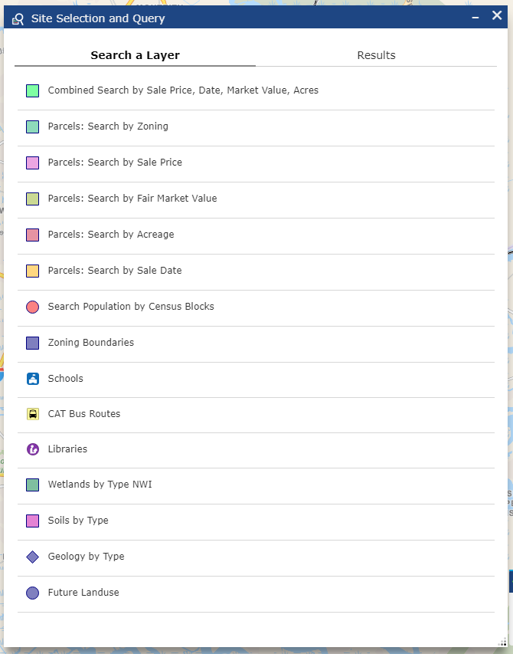

Shown below in the third screenshot is an example of the default query in the Combined Parcel Search by Sale Price, Date, Fair Market Value and Acres. If you leave it with the default values, it has been populated to find a very specific small group of parcels (by design, to demonstrate how it works as an example). To search by just **one** criteria, like to search by just ‘Sale Price’, click on that Search category.

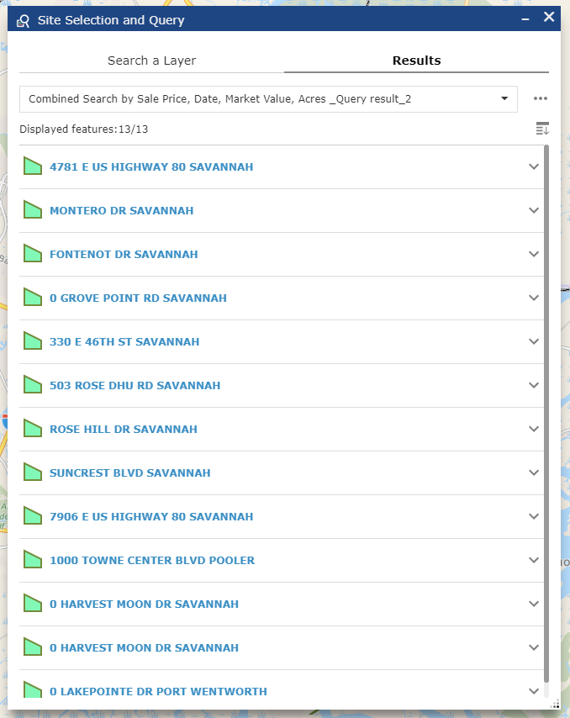

Click on a result to see its popup info box, rendered inside the Query window:

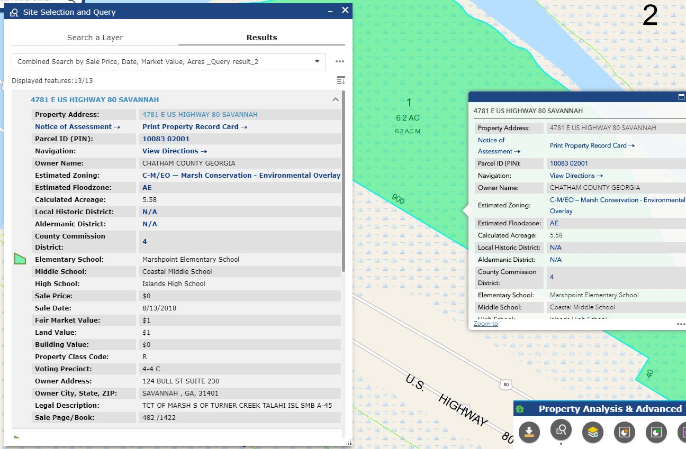

Click the Up arrow to roll up and minimize an individual result. 

Or click the Minimize All button to minimize them all, as shown in the screenshot above, where just the address for each result is visible. 🡪



Notice that the Query Result layer you create is added to the Layer List as a new layer. Its default name is simply ‘Combined Search by Sale Price, Date, Market Value, Acres_Query_result_#’. You can keep it in the Layer List and turn it on or off as needed. You can open this layer in the attribute table to then sort or download it, as described in the Layer List section of this Help Document. You can give your Query Result layer its own more specific name, such as ‘My Project 1: Query by Sale Price’ or so forth, by choosing a name in “Result Layer Name” above the ‘Apply’ button. To see your Query results, click the green ‘Apply’ button as below.

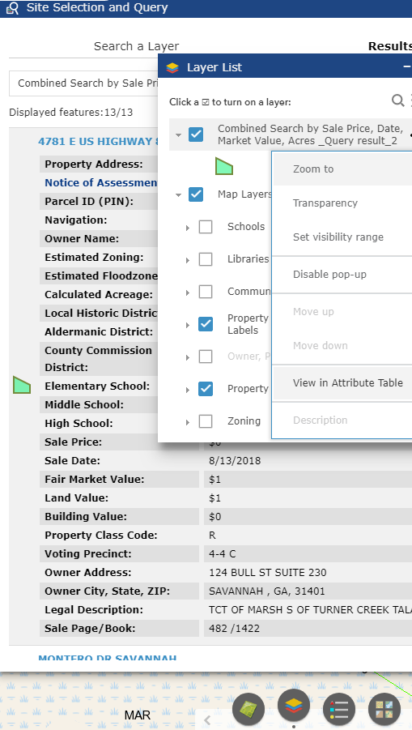 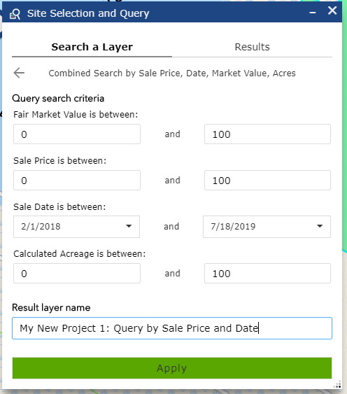

To take things to the next level of geographic analysis, you can **combine attribute queries** (querying by tabular conditions, such as the examples above) combined **with location by proximity** to features in other layers. Scroll down in the Query widget to reveal the Spatial Filter options.

For example, what if you wanted to see all of the Parcels of property with:

- a Sale Price between 0 and $100 AND a Fair Market Value between 0 and $100

- Zoning of R-A AND acres in size between 0 and 100 acres

- Sale Date between 2/1/2018 and 7/18/2019

- And… **within** **1 mile of Bike Paths**

This last condition is our new addition: Within 1 mile of Bike Paths. You can choose whether a feature is Within, Intersects, or Contains a feature in another layer. For example searching for Schools within a certain Zoning, or Parcels containing a certain Soil Type, and so forth.

You can optionally ‘Buffer’ this analysis, which is how we can find features within a certain distance of another layer’s features. Such as Parcels within 1 mile of Bus Routes, or Parcels that Intersect or Cross Over Bike Paths, for example. Click “Related Layer”, then “Map Layers”, and then choose a layer.

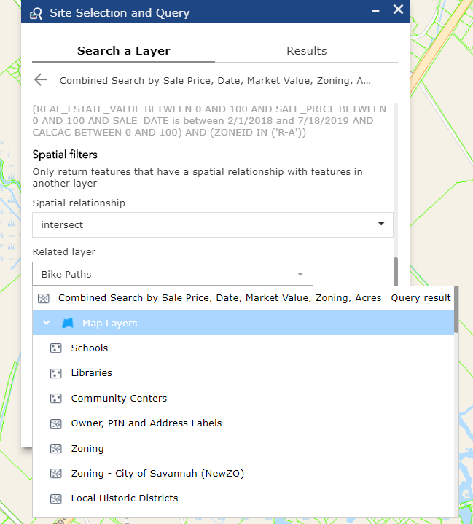Shown below is a Query meeting all of these tabular attribute conditions above, including ‘within 1 mile of Bike Paths’. It gives us only two results for parcels, that meet these very specific search conditions.

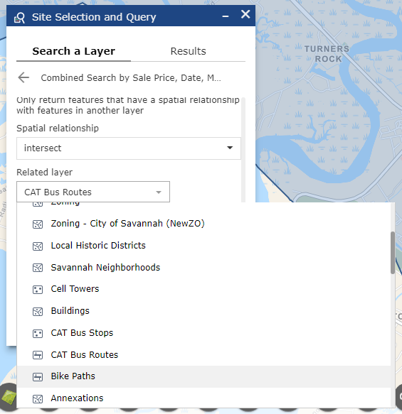

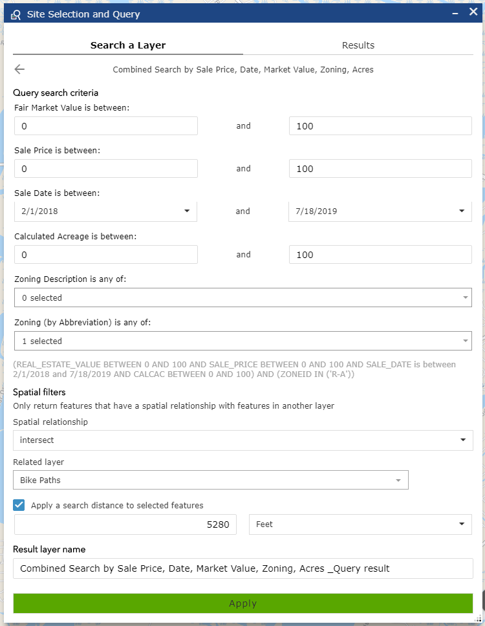

Shown below are the two parcels that match the criteria. Note the Structure Query Language (SQL) statement is presented to the user (above).

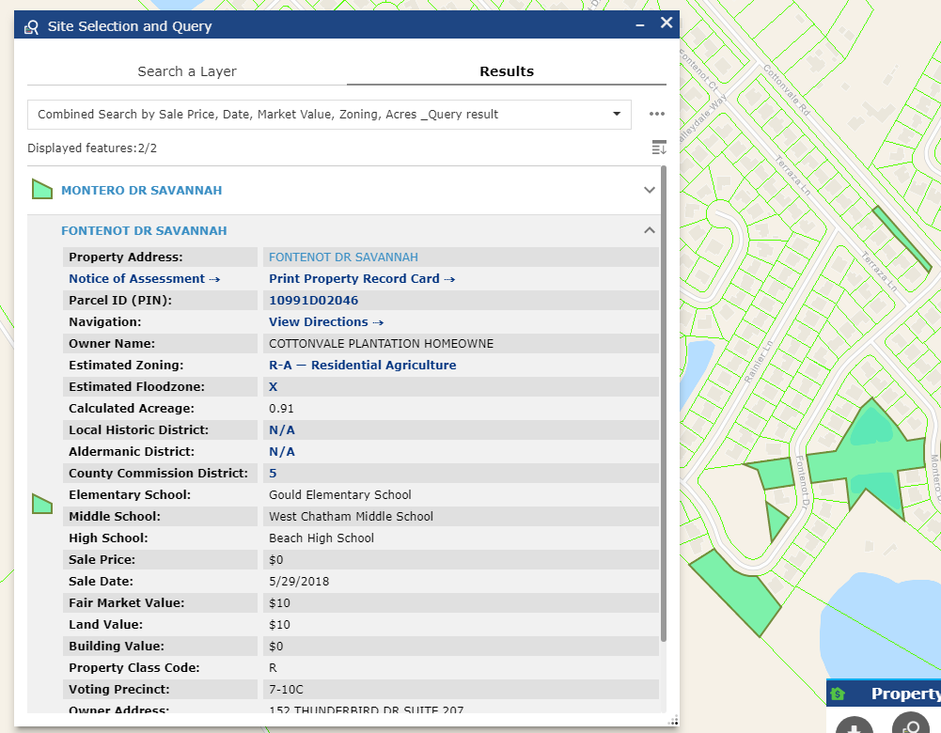

Another example shows Parcels with all these conditions, but within 3,280 feet of CAT Bus Routes, shown below. Note that you do NOT use a comma when entering values for feet or miles to buffer.

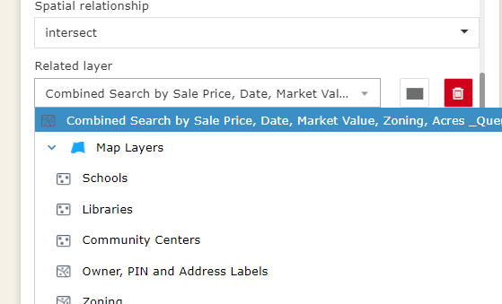You can also simply draw a rectangle around the area you want to apply the criteria to exclusively:

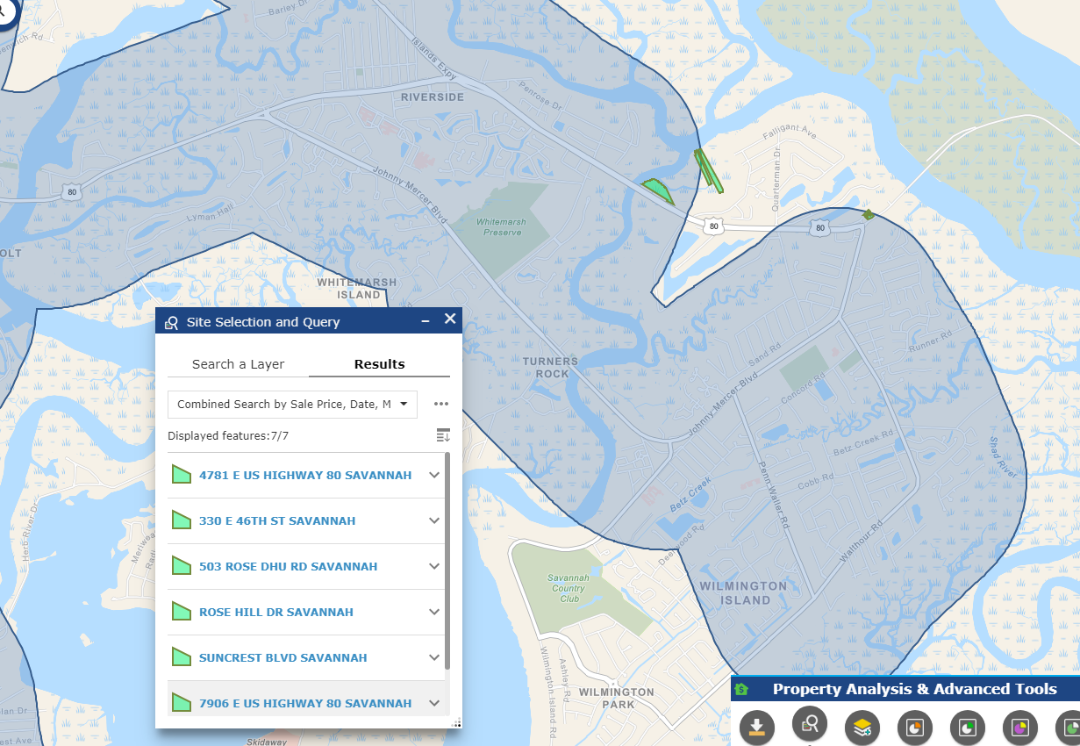

Notice how the distance buffer, in this case 3,280 feet within CAT bus routes, is shown on the map in the blue semi-transparent buffer overlay.

Closing the Query widget hides the results and the buffer (if one is present). Re-opening the widget will restore the previous Query. You can change the color and other options by clicking Options menu: …

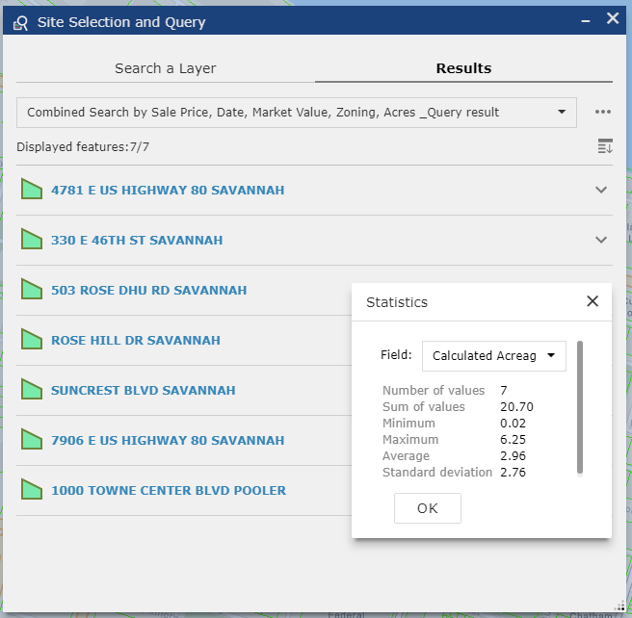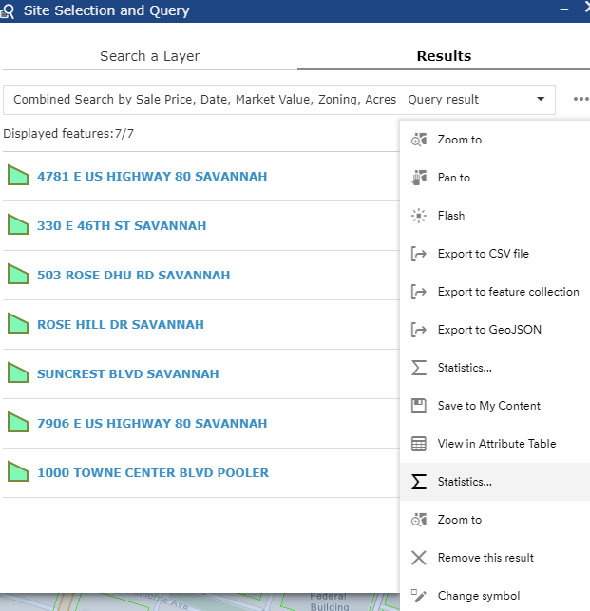Note also that you can display summary statistics for results, and export your results to a table file that Excel can open, as with other tools in this viewer.

To remove the Spatial Filter option, set the Related Layer to Chatham County and uncheck Buffer if it was turned on.

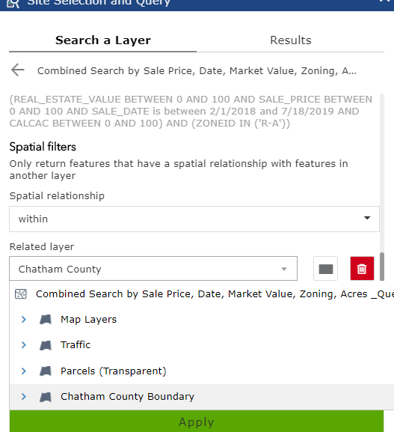



# Add Data

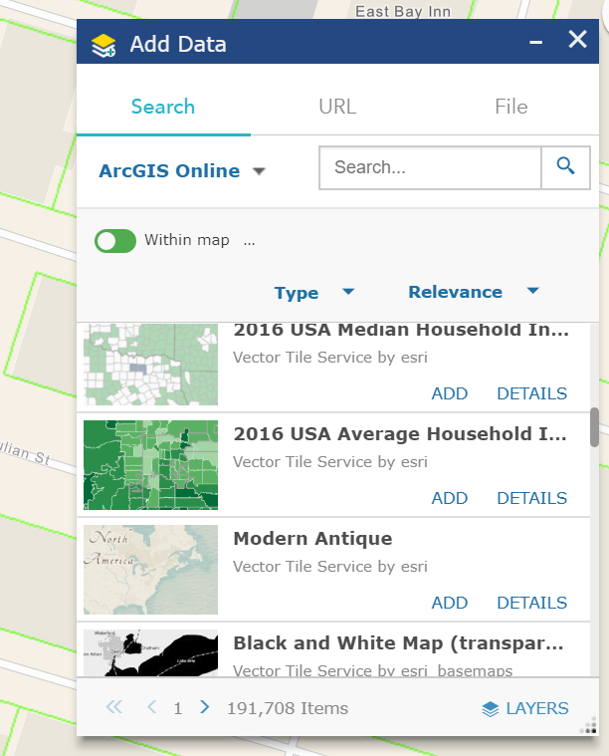The Add Data tool allows you to add additional map layers from other sources, such as other agencies and organizations. You can add data layers as web links from external servers as a link, or upload data from shapefiles, KML or CSV files.

You may search for data from

ArcGIS Online. Esri hosts data from many

sources on ArcGIS Online, functioning

essentially as a search engine for GIS data

around the world. Enter in a search word

relating to data that you want added to the

map, such as ‘military’ and then click the

Search button. Then click Add.

It will be added to the main Layer List.

Example of adding data: Military Bases and Military Tax Credit Census Tracts are shown as added.

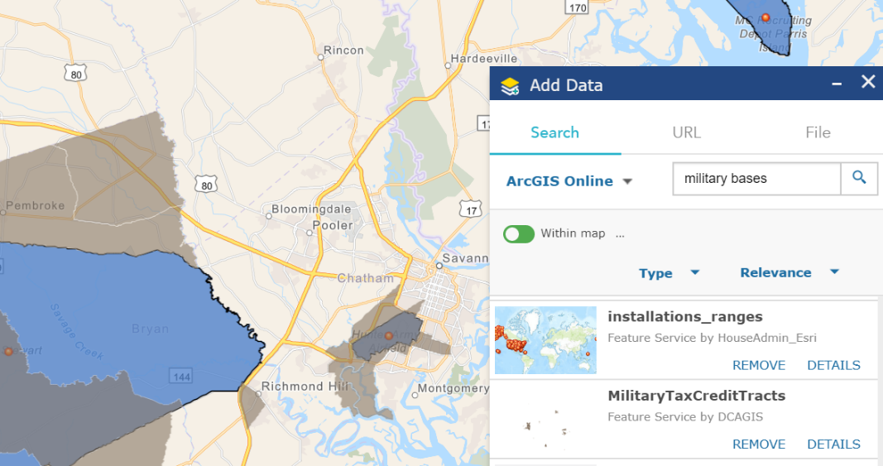

One interesting layer you can add, is satellite imagery from space. The NASA United States Geological Survey satellite “[Landsat](https://www.usgs.gov/faqs/what-are-acquisition-schedules-landsat-satellites?qt-news_science_products=0#qt-news_science_products)” flies over Savannah once every two weeks (as well as every other point on Earth through this two week cycle!). This means you can see satellite imagery of Savannah from within the past week or two. You could see the snow covering Savannah back in January 2018. Search for “landsat 8 pansharpened” or simply scroll down until you see **Landsat 8 Pansharpened** in the list. Then click Add. Note that when you add layers from the Add Data tool, they are added to the main Layer List as shown below. You can temporarily turn added layers off by unclicking their checkbox in the main Layer List or click Remove to remove them in the Add Data tool. In this example, we are showing the new warehouse buildings in Port Wentworth by Highway 21 and I-95. If you zoom in the imagery will be blurry, but that is because it’s from space. The pixel size is 15m (as on the ground) but it is useful for seeing large new construction. Additional multispectral remote sensing products (such as vegetation health with near infrared bands) are also available.

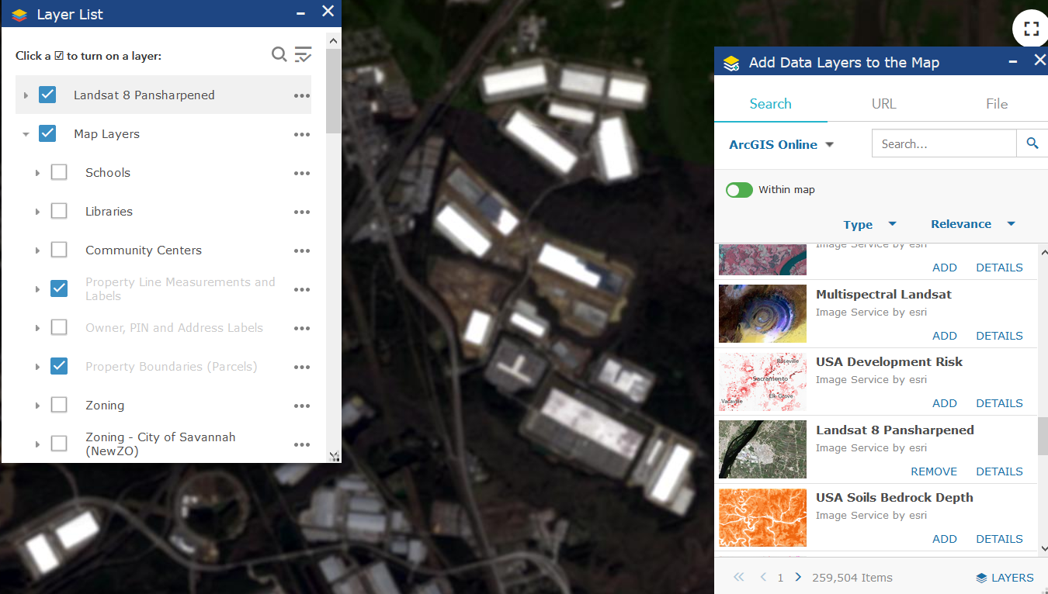

Note that it adds layers on the top. You can move layers up or down by clicking the ‘…’ Options button, as shown below. Click Move Down, and the turn on Roads in the main Map Layers layer section, to see roads over the imagery:

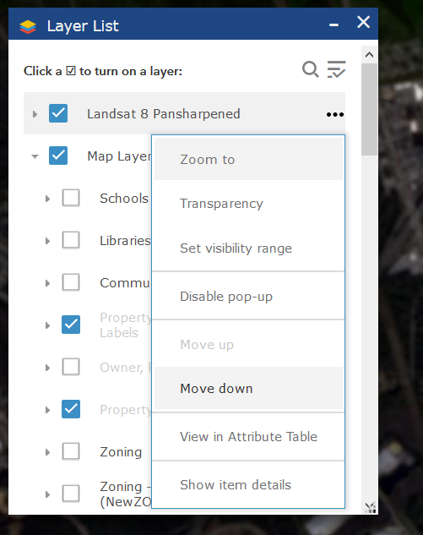

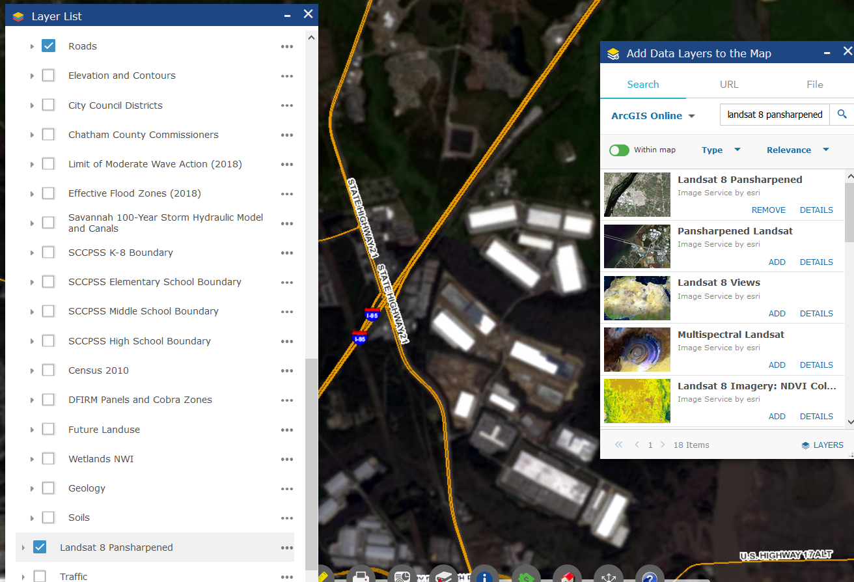



# Charts: Sale Price, Value and Zoning

The Charting widgets create bar charts for Sale Price, Fair Market Value, Land and Building Value and a pie chart of Zoning, for areas you select by drawing on the map or searching with the  Property Search widget, which will open automatically when you open one or more of the Chart widgets.

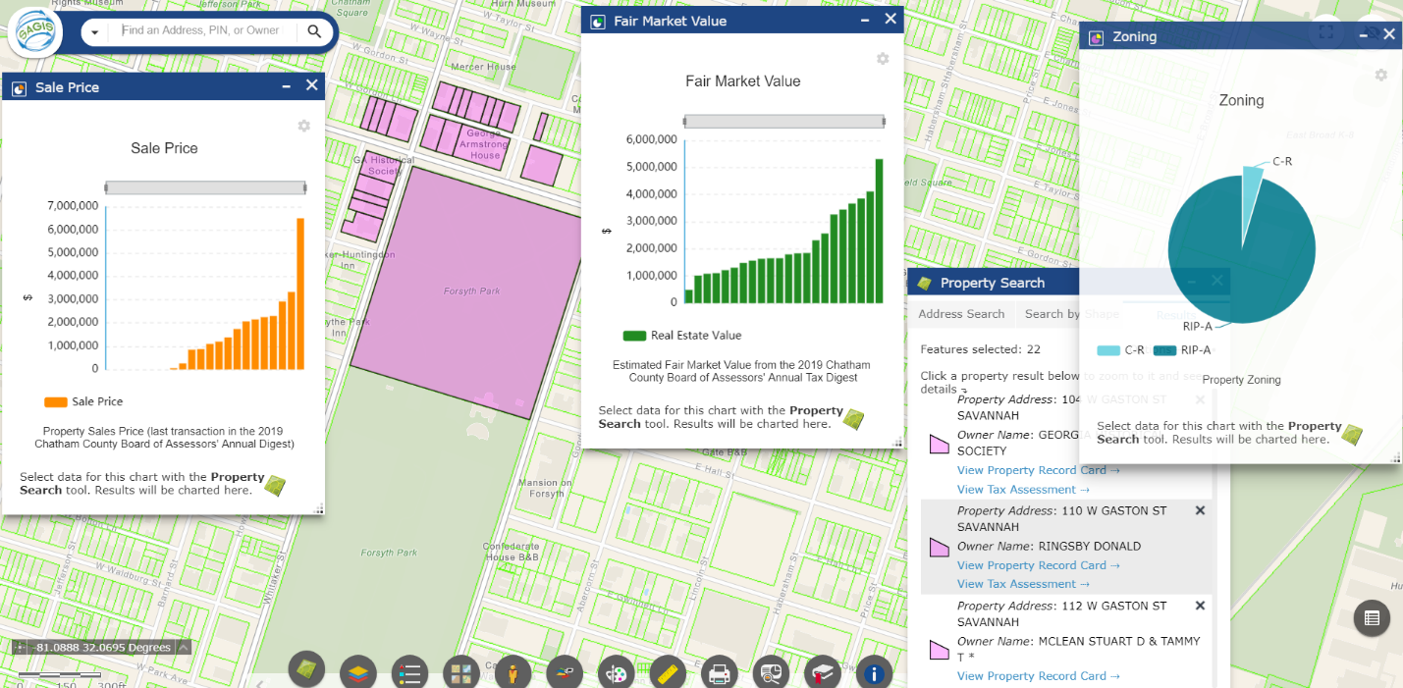

Hover your mouse over a bar to see the address for that specific bar:

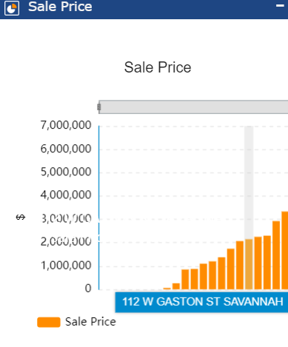

# Select and Download Data

The Select tool lets you select layers, similar to Identify, but it also lets you download them to a CSV table file to open in Excel, view them in the attribute table, or view Statistics, as shown below. Note that layers **must** be **turned** **on** and visible in the Layer List, in order to be able to be selected. Then, you must choose which layer you want to select in the Select widget, by clicking its checkbox.

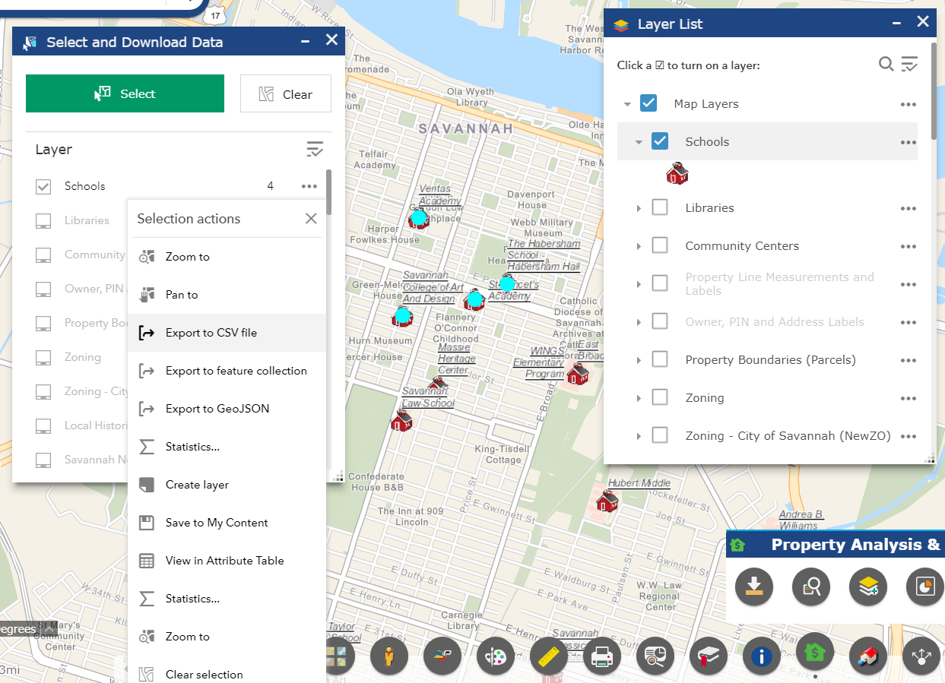

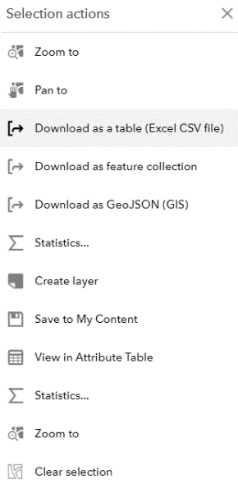



# Help and About

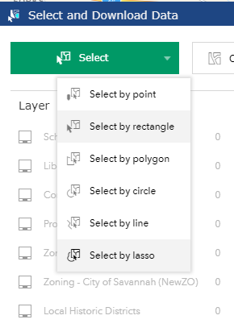You can select by various shapes if you click the dropdown button on the right side of the Select button:

To view Statistics, like Sum, Average, Min and Max values, Click Statistics as below.

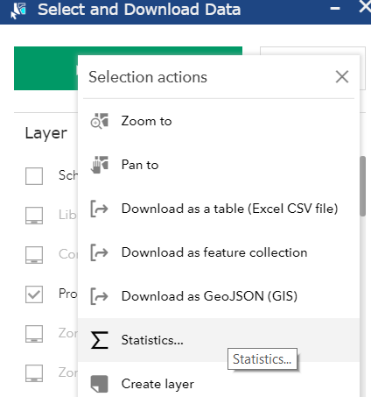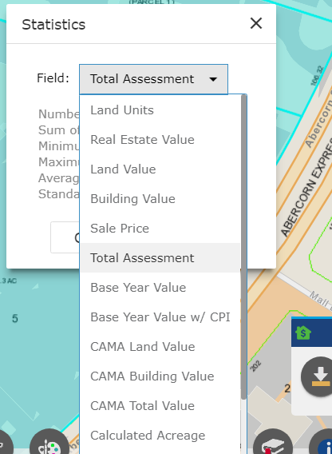

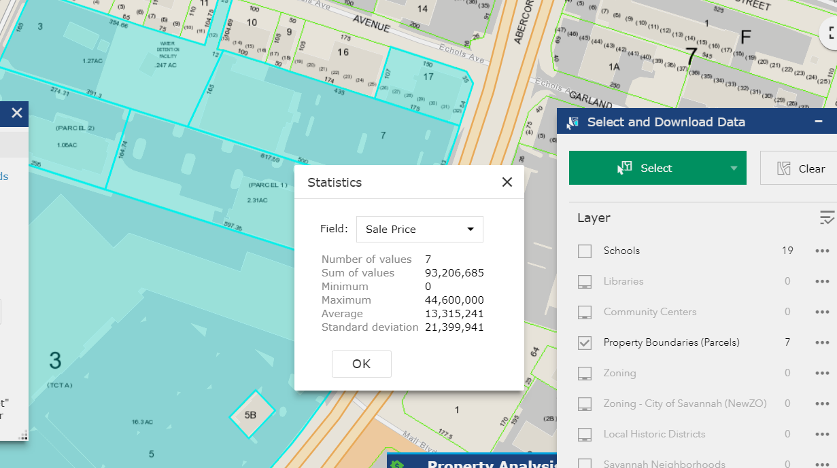

Click the ‘Field’ to choose which attribute field (column, in the attribute table) you want to see stats for.

‘Create Layer’ saves the selected feature or features as its own layer that will appear at the top of the layer list. This can be a handy way to show just these features, and turn off the rest of the layer, such as to show only a few schools on the map, not all of them across the county. This is similar to the Filter option in the Attribute Table, only achieved by selecting graphically by drawing, versus selecting by an attribute criteria. In the example below, a subset of three Schools and of a few Parcels are shown.

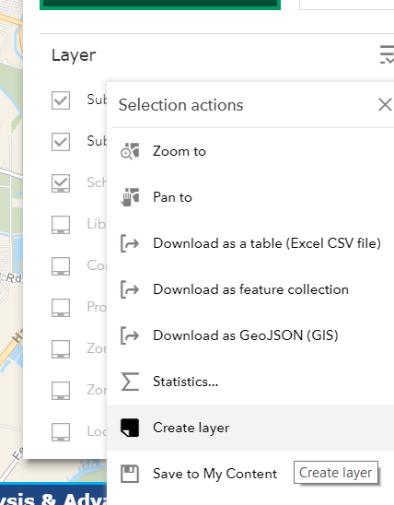

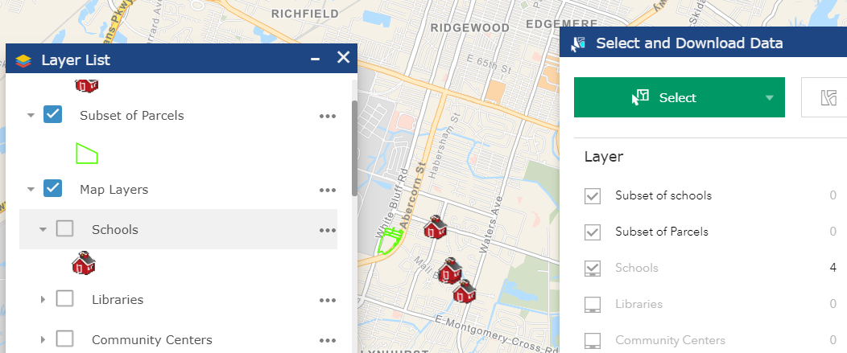

# Distance and Direction

The Distance and Direction measurement tool can measure lines and circles of a given buffer distance radius. Lines can be drawn by coordinate geometry, or by clicking points on the map by hand. Coordinate geometry can be entered in various formats as shown below including decimal degrees and military grids, US National Grid and others.

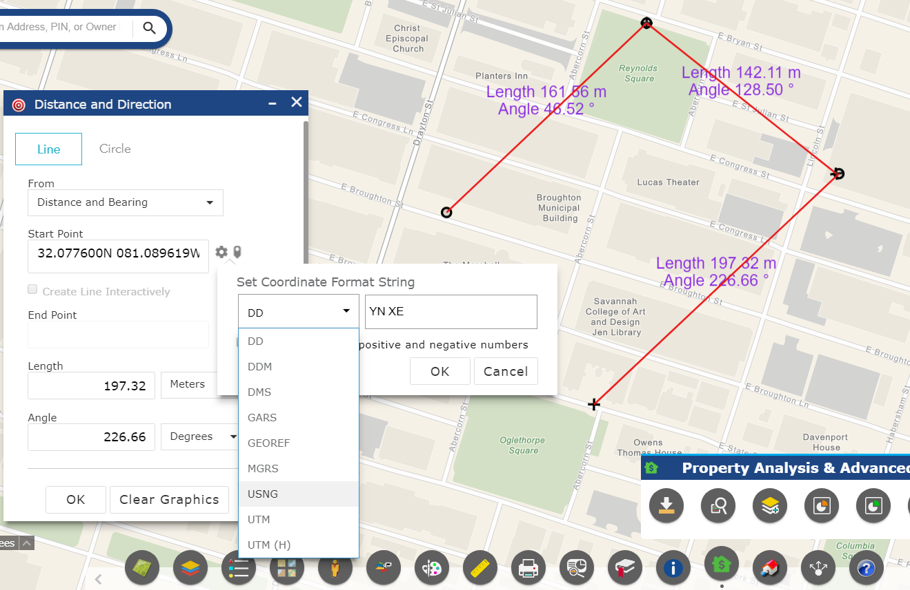

Enter coordinates and an angle and length and click OK. Repeat this step to create multiple line segments. To create lines by simply clicking on the map, in order to have direction bearing and length measured, click “Create Line Interactively” and then click the  button to place a point.

To create circles with a specific radius (to create a buffer), click Circle. Enter a distance and a unit, such as Feet, and then click on the map where you want the circle centered.

If you click “Create Circle Interactively” you click on the map, and then as you stretch out the circle, you will see the distance update as it increases, in real time.

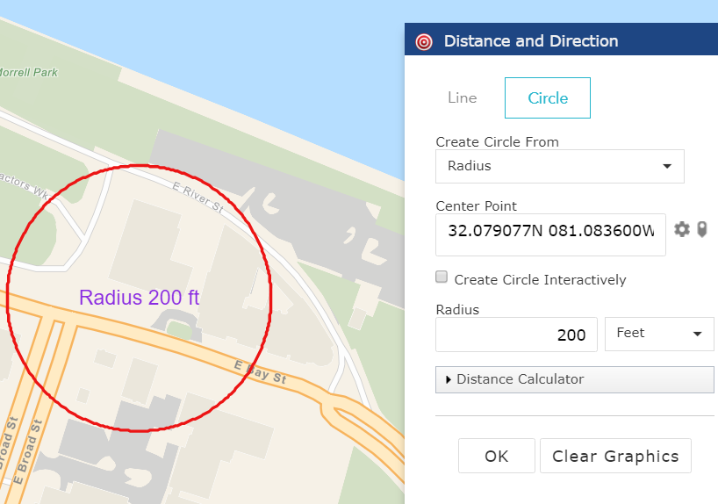

# **Grid Overlay**

The Grid Overlay tool creates a grid with rows and columns of a given width. You can specifiy the number of columns and rows and it will create the grid.

The grid overlay can be useful if you are creating maps to print and use for fieldwork and data collection for example, or simply for a frame of reference if you are printing a map and referring to different parts of the map such as in a meeting or presentation.

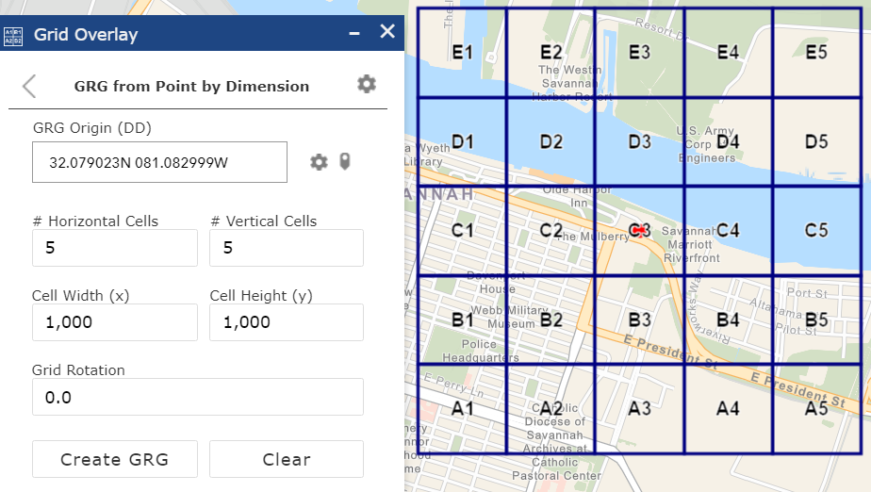

On the flip side, you can specify an area and the number of rows and columns you want, and then it will automatically determine the width and height, with the rows and columns spaced evenly. The overlay can be in a specified projection and coordinate system as specified by the user.

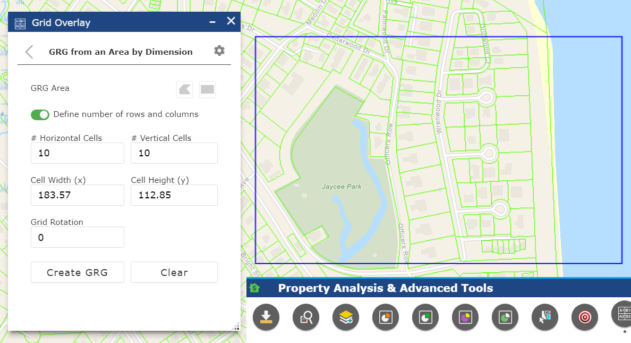

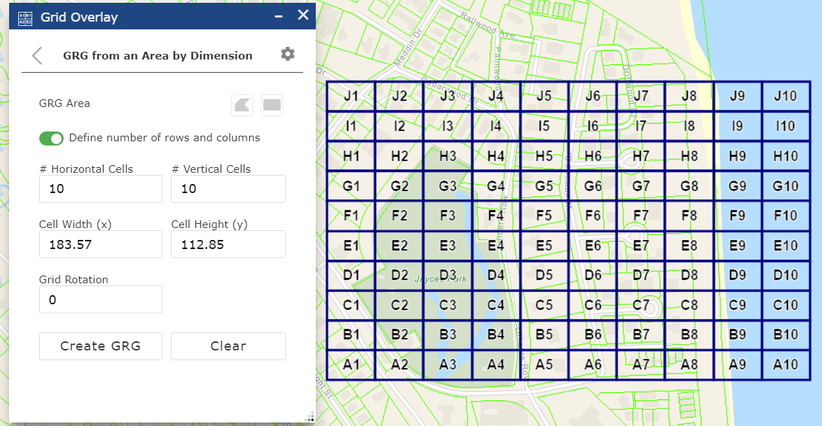

Options are accessed by clicking the settings gear button.  You can change the color of the lines and labels, add halo around label text, and choose grid shape such as rectangle or hexagon.

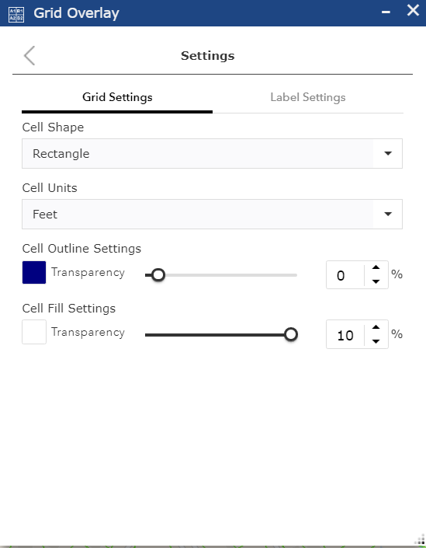 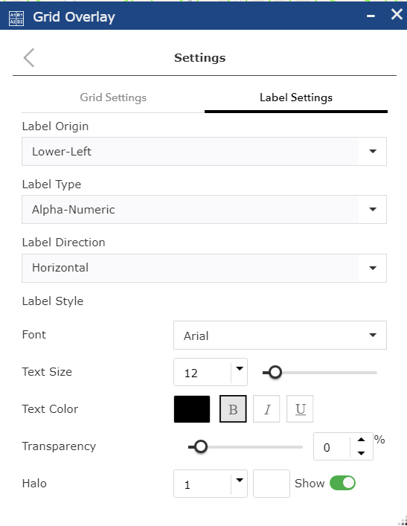



# Help and About

The About button contains a link to this Read Me help document, links to our instructional videos on YouTube showing how to use this map viewer, general information about the viewer and SAGIS contact information.

# Pictometry

The SAGIS Map Viewer Pictometry tool opens a completely web-based Pictometry Viewer, which is intended to replace the legacy Pictometry EFS desktop application. After activating the tool, click a point on the map and the Pictometry window will open, centered at the point the user has clicked upon. You may display oblique aerial photography facing north/east/south/west, orthorectified aerial imagery, or a street basemap. You can measure both horizontal and vertical distance, as well as locate addresses and parcels by both street address and PIN. Vector data such as parcel boundaries, street centerlines, and address points can be displayed over the imagery. All years of imagery for which SAGIS has collected Pictometry imagery are viewable as well.

The Pictometry button () activates the Pictometry tool. Once this tool is activated, when the user clicks on the map, a new window or tab (depending on user preferences) will open in the browser. In this tab, a new viewer will load, which displays oblique aerial photography (Pictometry imagery) for the years it has been collected in Chatham County. The imagery will be centered on **where** the user clicked on the map.

This imagery is similar to Google’s 45-degree view or Bing Maps Bird’s Eye view, in that it allows you to see the imagery from an angle, and rotate in the four compass directions (north, east, south and west). It is also allowing you to zoom in very close on the imagery to a fine scale. You can zoom in and out of imagery with the mouse wheel, like the main viewer, or click +/- buttons in the upper left of the viewer window. Left-clicking the mouse and dragging the map moves your position, as in the main viewer.

In the upper-left corner, the rotator control allows you to rotate imager north/east/south/west.

Two examples below show imagery of the Talmadge Bridge, from the north and the south. Notice how you can see under the bridge, because the imagery is captured from an angle.

Example of Pictometry imagery from the North:



Example of Pictometry imagery from the South:

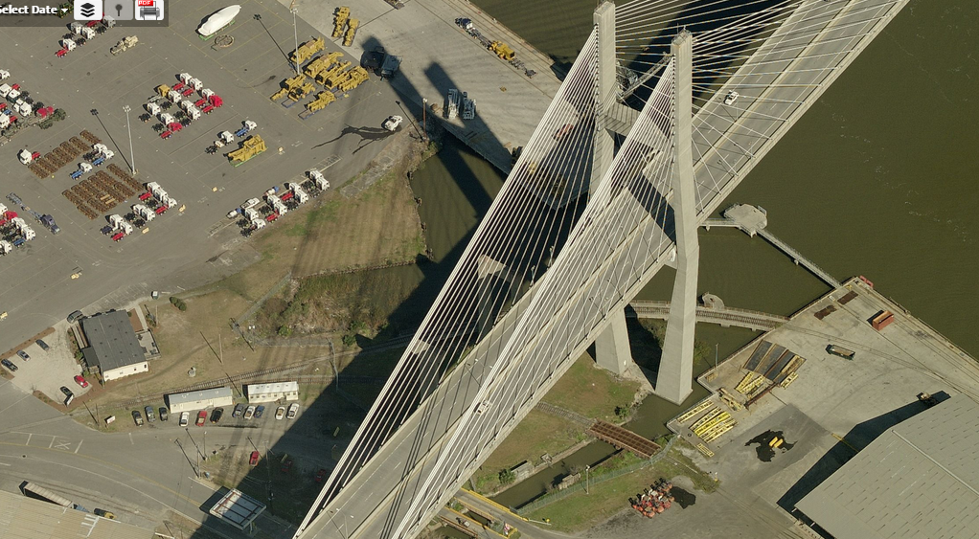

The Select Date tool allows you to view imagery from the following years. Click the dropdown menu to view the available years as in the next screenshot, where 2013 imagery of Forsyth Park is being displayed.

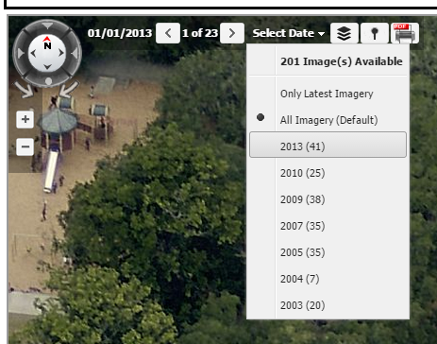

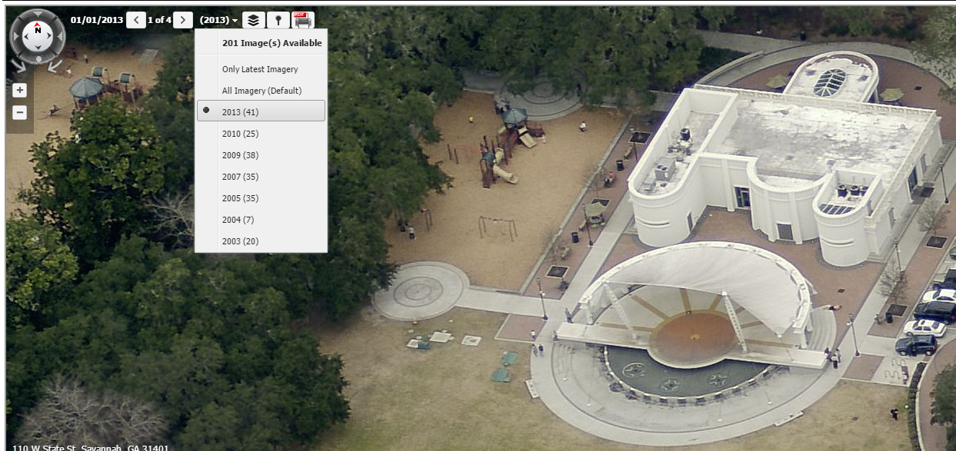

Notice if we select year 2005, we can see that the band shell is still under construction:

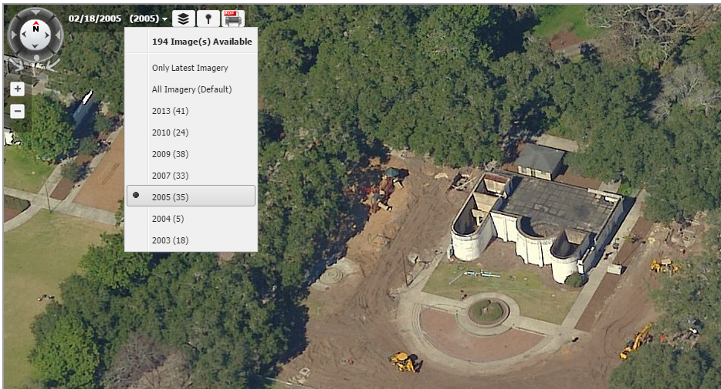

The Layers button () can turn on the parcel layer and street name and street address layers, as shown below:

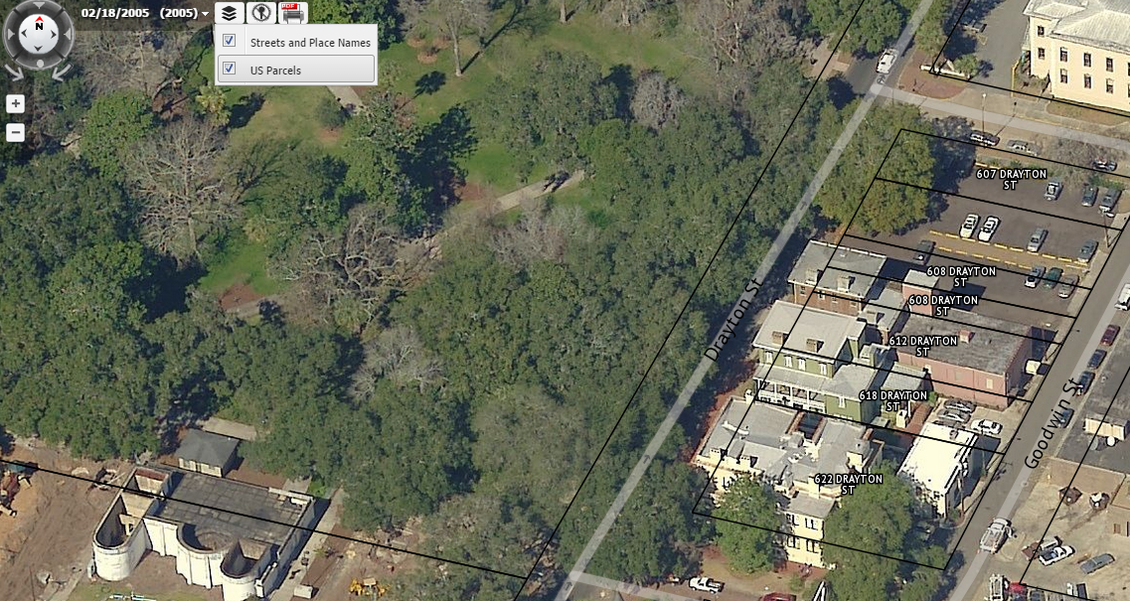

# 5.0**SAGIS CONTACT INFORMATION**

SAGIS Contact Information

For questions about this document or help with this website, or other SAGIS products and data, please contact a SAGIS staff member.

**Kevin MacLeod**, GIS Programmer / Analyst (912)-651-1452 / [macleodk@thempc.org](mailto:macleodk@thempc.org)

**Lara Hall**, Director (912)-651-1451 / [halll@thempc.org](mailto:halll@thempc.org)

**MPC Main Line** (912)-651-1440

Visit our website to learn about SAGIS, Geographic Information Systems (GIS), and view documention on SAGIS products and services at <http://www.thempc.org/Dept/Sagis> . To view the SAGIS internal homepage on the city or county network visit <https://gov.sagis.org>. If you are not on a city or county computer, you may also VPN in to connect to the internal network. Contact your network administrator or IT department for access.